

APRIL 2016

This document was produced for review by the United States Agency for International Development. It was prepared by Cloudburst Consulting Group, Inc. for the Evaluation, Research, and Communication (ERC) Task Order under the Strengthening Tenure and Resource Rights (STARR) IQC.

Mobile Application To Social Tenure Pilot Project (MAST)

User Manual for the Mobile Application

Prepared for the United States Agency for International Development, USAID Contract Number AID-OAA-TO-13-00019, Evaluation, Research and Communication (ERC) Task Order under Strengthening Tenure and Resource Rights (STARR) IQC No. AID-OAA-I-12-00030.

Implemented by:

Cloudburst Consulting Group, Inc.

8400 Corporate Drive, Suite 550

Landover, MD 20785-2238

Mobile Application to Social Tenure Pilot Project (MAST)

User Manual for the Mobile Application

APRIL 2016

**DISCLAIMER**

The authors' views expressed in this publication do not necessarily reflect the views of the United States Agency for International Development or the United States Government.

taBLE OF CONTENTS

[1. Document Overview 3](#_Toc447797900)

[2. About MAST Application 3](#_Toc447797901)

[3. Installation Steps 4](#_Toc447797902)

[4. Login 4](#_Toc447797903)

[5. Map Viewer 6](#_Toc447797904)

[5.1 Layer Manager 7](#_Toc447797905)

[5.2 GPS 8](#_Toc447797906)

[5.3 Get location co-ordinates 9](#_Toc447797907)

[5.4 Measure 10](#_Toc447797908)

[5.4.1 Calculate Distance 11](#_Toc447797909)

[5.4.2 Calculate Area 12](#_Toc447797910)

[5.4.3 Measure Polygon Area 13](#_Toc447797911)

[5.4.4 Measure Line Length 13](#_Toc447797912)

[5.5 map Info Tool 14](#_Toc447797913)

[5.6 Add/View Bookmark 15](#_Toc447797914)

[5.6.1 Add Bookmark 15](#_Toc447797915)

[5.6.2 View Bookmark 16](#_Toc447797916)

[6. Download Data 17](#_Toc447797917)

[7. Verify Data 18](#_Toc447797918)

[7.1 Pending 18](#_Toc447797919)

[7.1.1 View Map 19](#_Toc447797920)

[7.1.2 View Attributes 20](#_Toc447797921)

[7.1.3 Mark as Verified 21](#_Toc447797922)

[7.2 Verified 22](#_Toc447797923)

[7.3 Final 22](#_Toc447797924)

[8. Capture Data 23](#_Toc447797925)

[8.1 Layer Manager 24](#_Toc447797926)

[8.2 Zoom to Current Location 25](#_Toc447797927)

[8.3 Add Bookmark 26](#_Toc447797928)

[8.4 View Bookmark 26](#_Toc447797929)

[8.5 Add Feature 27](#_Toc447797930)

[8.5.1 Capture Point 27](#_Toc447797931)

[8.5.1.1 Draw Point 28](#_Toc447797932)

[8.5.1.2 Capture point by GPS 29](#_Toc447797933)

[8.5.1.3 Enter Location 29](#_Toc447797934)

[8.5.2 Capture Line 30](#_Toc447797935)

[8.5.2.1 Draw Line 31](#_Toc447797936)

[8.5.2.2 Capture Line by GPS 31](#_Toc447797937)

[8.5.3 Capture Polygon 32](#_Toc447797938)

[8.5.3.1 Draw Polygon 32](#_Toc447797939)

[8.5.3.2 Capture Polygon by GPS 33](#_Toc447797940)

[8.6 Capture Attribute 34](#_Toc447797941)

[8.7 Edit Spatial 44](#_Toc447797942)

[8.8 Delete Feature 46](#_Toc447797943)

[8.9 Measure 48](#_Toc447797944)

[8.9.1 Calculate Distance 48](#_Toc447797945)

[8.9.2 Calculate Area 49](#_Toc447797946)

[8.9.3 Measure Polygon Area 49](#_Toc447797947)

[8.9.4 Measure Line Length 50](#_Toc447797948)

[8.10 Map Info Tool 51](#_Toc447797949)

[9. Review Data 52](#_Toc447797950)

[9.1 Draft List 53](#_Toc447797951)

[9.1.1 Edit Spatial 54](#_Toc447797952)

[9.1.2 Edit Attribute 55](#_Toc447797953)

[9.1.3 Delete Entry 56](#_Toc447797954)

[9.1.4 Mark as complete 57](#_Toc447797955)

[10. Download Data 59](#_Toc447797956)

[11. Synchronize Data 60](#_Toc447797957)

[12. User Preferences 61](#_Toc447797958)

[12.1 Change Language 62](#_Toc447797959)

[12.2 Configure Data Collection Tool 62](#_Toc447797960)

[12.3 Configure Auto Sync 63](#_Toc447797961)

[12.4 Configure Map Display 63](#_Toc447797962)

[12.4.1 Point 63](#_Toc447797963)

[12.4.2 Line 64](#_Toc447797964)

[12.4.3 Polygon 64](#_Toc447797965)

[13. Logout 65](#_Toc447797966)

1. Document Overview

This document intends to give the guidelines to MAST mobile application users (Trusted Intermediaries and Adjudicators), for usage of MAST mobile data capture application.

This mobile data capture application has been designed to work on Android based hand-held devices only and facilitates the field users to capture data of parcels (spatial units) in field along with its attribute and multimedia information.

Pre-requisite:

1. Android application (apk) file should be installed on the device.
2. Internet connectivity should be available to download the data before initiation of data capturing work.
3. About MAST Application

The key objective of MAST is to provide a framework for Capturing Land rights information using a participatory approach. This framework provides a suite of applications to support collection and management of land rights information with following key components:

**Mobile Data Capture Application –** Mobile data capture application is an Android based Mobile application to capture land rights information (spatial, alphanumeric and multimedia) on mobile devices in field.

Mobile application will be provided to conduct data collection work without being connected to a central cloud based server in offline mode. Data will be collected and stored on users’ handheld device and once the user is within the influence region of the internet, where data could be synced, the information will be packaged and sent back to the server.

**Land Rights Data management Infrastructure application** – Data collected on mobile devices will be transferred to a cloud based land Rights Data Management Infrastructure application which will provide tools to ingest, manage and store data of land rights information. It will also provide reporting components so that required Land Rights reports can be generated.

This document provides detail of Mobile component of MAST application.

1. Installation Steps

Steps of install Application in Mobile and configuration of Spatial Data:

1. Copy LandRightsDataCapture.apk in the device
2. Tap on the app to install the application
3. Login into the application to create necessary folders/db
4. Copy the test\_vector.mbtiles file into \MTP\spatialdata folder
5. Login

This functionality will allow authorized users to Login into the application.

**Steps:**

1. User provides valid User Name and Password
2. 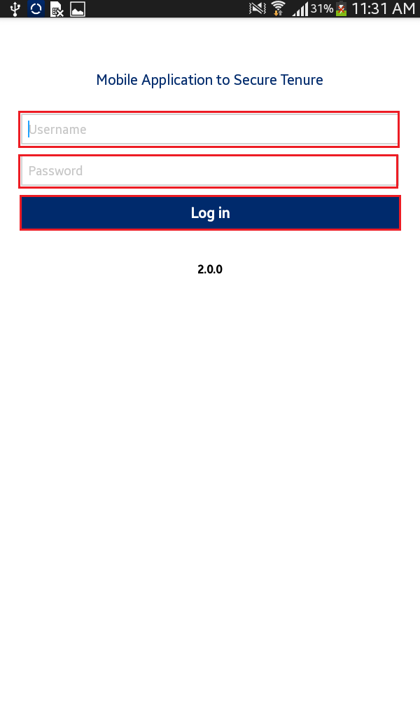Click on ‘Login’ button
3. 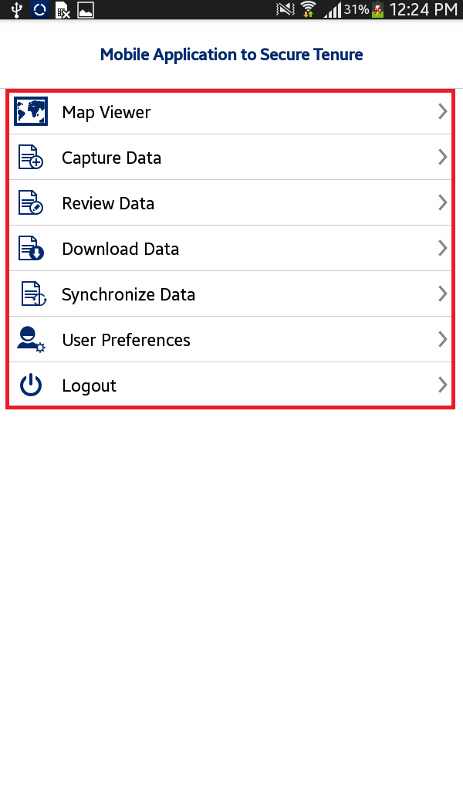Application will open up homepage of application
4. Following functionalities are visible:
   * + Map Viewer
     + Capture Data
     + Review Data
     + Verify Data
     + Download Data
     + Synchronize Data
     + User Preferences
     + Logout

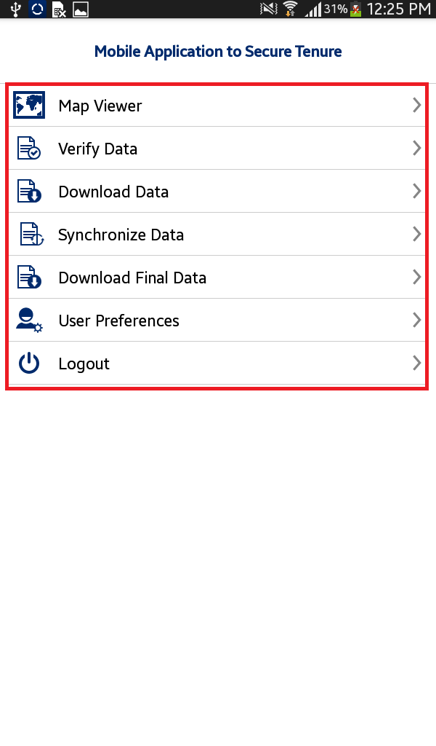

**Note – If ‘Adjudicator’ user login into the MAST, Following functionalities are visible:**

* + - Map Viewer
    - Verify Data
    - Download Data
    - Synchronize Data
    - Download Final Data
    - User Preferences
    - Logout

1. Map Viewer

This functionality will allow authorized user/s to view spatial data of parcels and download base map. Overall, map viewer will display following data layers:

* + - Base map (Satellite data downloaded from server)
    - Google base map
    - Collected parcel data (if collected by the user)

This functionality provides following facilities:

* + - 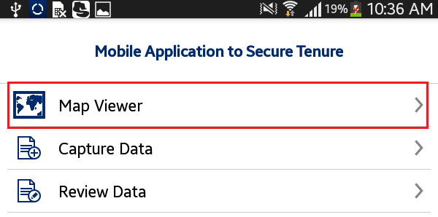View Base Data on map
    - Capture Spatial Data
    - Review Captured Data
    - Navigation Tools
    - Mapping Tools
      * Zoom to location
      * Enter X and Y coordinates
      * Measure
      * Info

**Steps:**

1. User clicks on ‘Map Viewer’ option available on home page
2. Application will open up Map Viewer. Following tools are available with map viewer
   * + 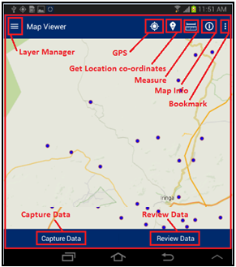Layer Manager
     + GPS
     + Get Location co-ordinates
     + Measure
     + Map Info
     + Bookmark
     + Capture Data
     + Review Data

# Layer Manager

This functionality provides the listing of layers configured for the selected project. User can On/Off display of a particular layer from the Layer Manager to view on the map.

**Steps:**

1. 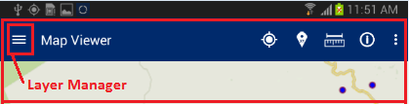User click On Layer Manager option available on Top Left
2. 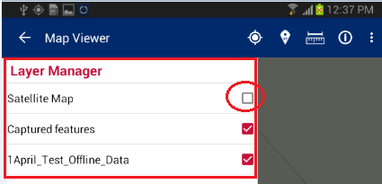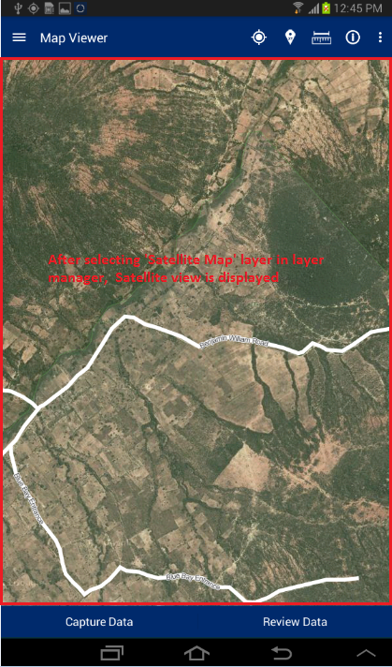List of layers configured for the selected project will be displayed along with a check box Check/Uncheck the checkboxes on Layer Manager to show/hide a particular layer on the map
3. Selected Layer will become available on map

# GPS

This functionality facilitates user to navigate the map to the current location.

**Steps:**

1. User tap on ‘GPS’ option available on top right
2. 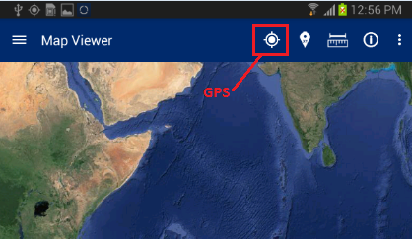Map will navigate to the current location

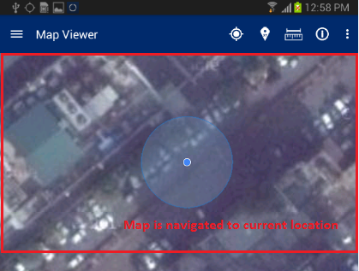

# Get location co-ordinates

This functionality facilitates user to get Coordinates values of specified location of map.

**Steps:**

1. 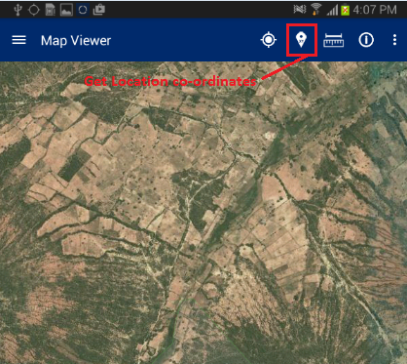User tap on ‘Get location Co-ordinates’ option available on top right
2. Click on map
3. 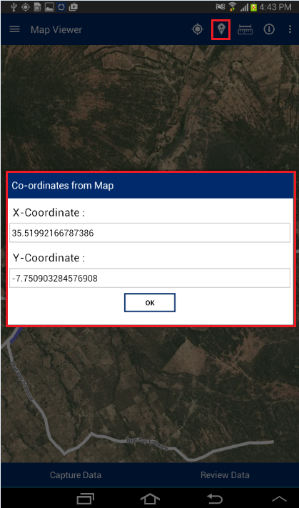‘Co-ordinates from Map’ dialogue box will be displayed with coordinates of location specified by click on map

# Measure

This functionality facilitates user to measure the area of any polygon, Length on any line or the distance between two points on map.

**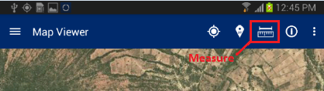Steps:**

1. User tap on ‘Measure’ option available on top right
2. 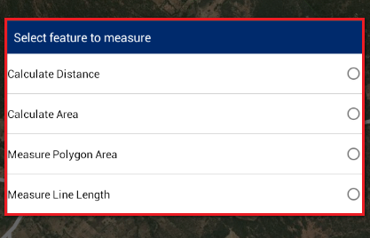‘Select feature to measure’ dialogue will be displayed with following options –
   * + Calculate Distance
     + Calculate Area
     + Measure Polygon Area
     + Measure Line Length

## Calculate Distance

This functionality facilitates user to calculate the distance between two or more subsequent points on map.

**Steps:**

1. 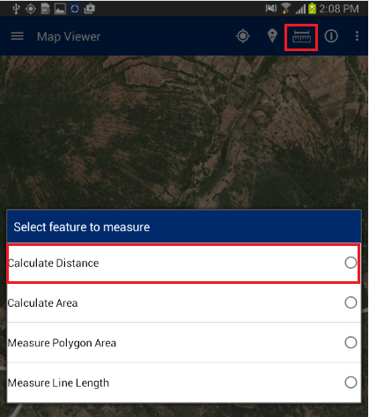Tap on ‘Measure’ option available on top right
2. Select ‘Calculate distance’ option
3. 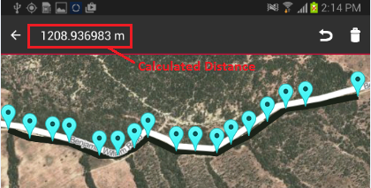Click on map to specify at least two points
4. Application will calculate Distance and display it on top right of application

## Calculate Area

This functionality facilitates user to calculate the area of polygon by specifying it on map.

**Steps:**

1. 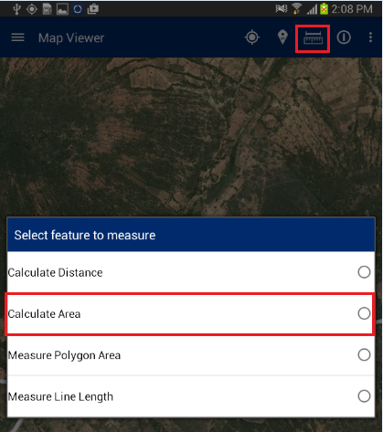Tap on ‘Measure’ option available on top right
2. Select ‘Calculate Area’ option
3. Click on map to specify at least three points
4. 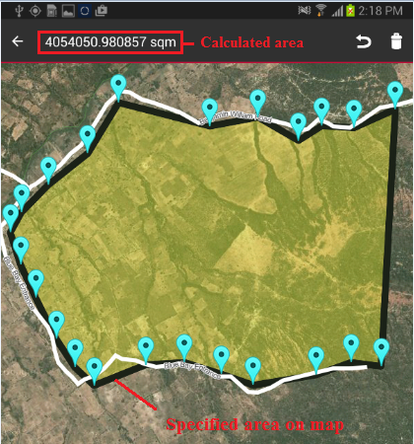Application will calculate Area and display it on top right of application

## Measure Polygon Area

This functionality facilitates user to calculate the area of existing polygon feature by specifying it on map.

**Steps:**

1. 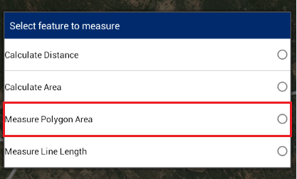Tap on ‘Measure’ option available on top right
2. Select ‘Measure Polygon Area’ option
3. Click on existing polygon feature map
4. Application will calculate Area and display it on map only

## Measure Line Length

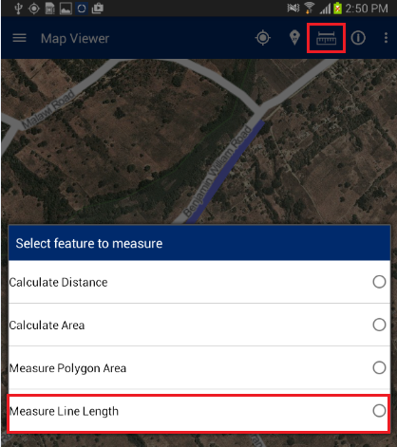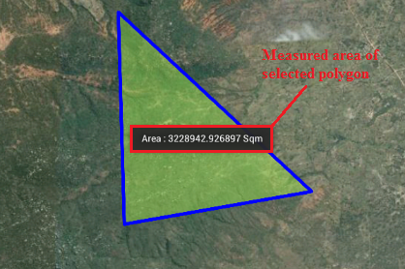This functionality facilitates user to calculate the length of existing line feature by specifying it on map.

**Steps:**

1. Tap on ‘Measure’ option available on top right
2. Select ‘Measure Line Length’ option
3. Click on existing Line feature map
4. Application will calculate Length and display it on map only

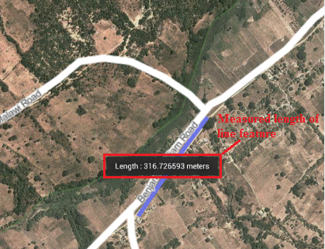

# map Info Tool

This functionality facilitates user to View the attribute details of any spatial feature which is already created on map.

**Steps:**

1. 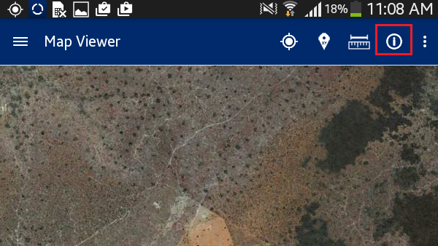Navigate to existing feature on map

Tap on ‘Map Info’ option available on top right

1. Click on feature on map
2. 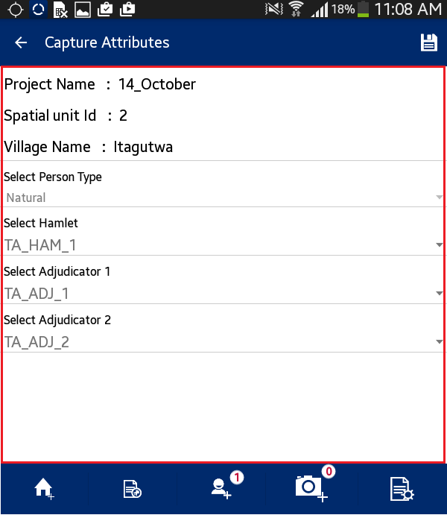Attribute details of specified feature will be displayed

# Add/View Bookmark

Bookmarks tool facilitate users to save a particular area of interest of map canvas for future reference. It also facilitates user to navigate a selected bookmark.

**Steps:**

1. 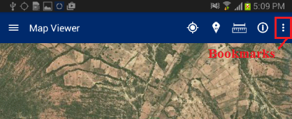Tap on ‘Add/View Bookmark’ option available on top right
2. 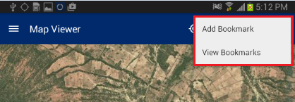Application will display two options.
   * + Add Bookmark
     + View Bookmark

## Add Bookmark

Bookmarks tool facilitate users to save a particular area of interest of map canvas to save for future reference.

**Steps:**

1. 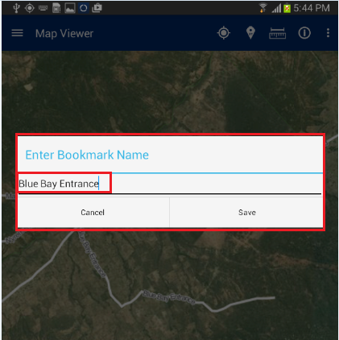User clicks on ‘Add Bookmark' option
2. Enter Bookmark dialogue box will be displayed
3. Enter desired name in input box
4. Click on ‘Save’ button
5. Bookmark will be saved with entered name and will become available in ‘Select Bookmark' dialogue

## View Bookmark

This functionality facilitates user to navigate a selected bookmark.

**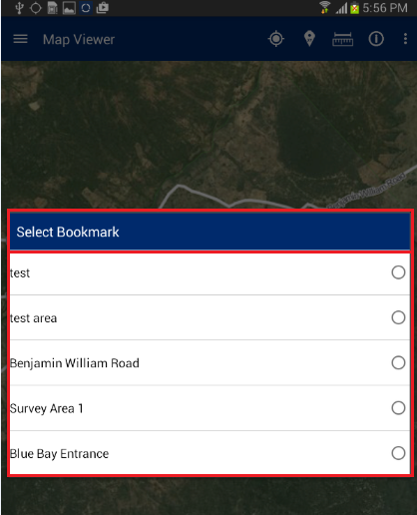Steps:**

1. User Clicks on ‘View Bookmark' option
2. ‘Select Bookmark' dialogue box will be displayed with list of all bookmarks available
3. Select required bookmark
4. 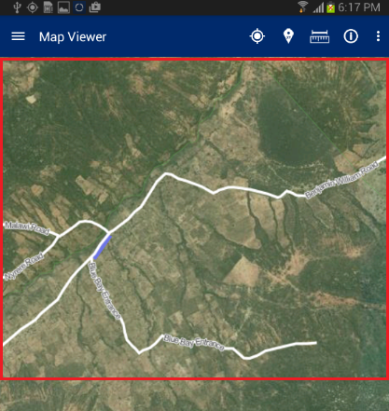Map will navigate to the location saved with selected bookmark
5. Download Data

‘Download Data’ facilitates user to download configuration information and base data (Satellite imagery and vector data which will be used as reference for data collection process) on the device. To download data, mobile device should be in connected mode i.e. Internet should be available in device.

**Steps:**

1. 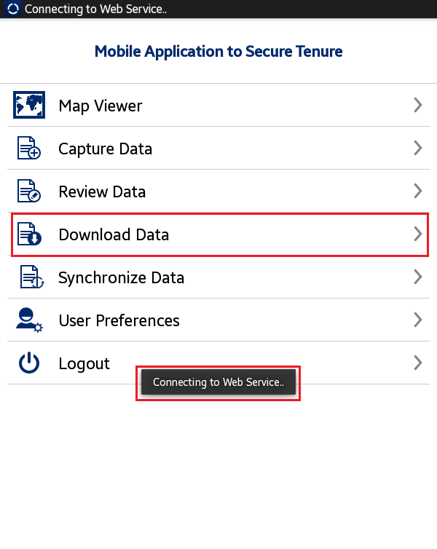User clicks on ‘Download Data’ option available in homepage
2. Application will connect to the remote server and download required data
3. 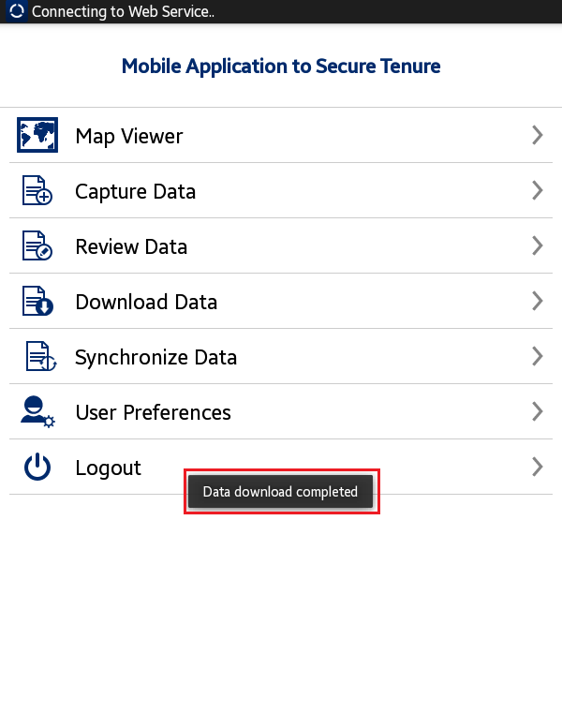Once Data Download is completed, an acknowledgement message will be displayed

1. Verify Data

This functionality facilitate Adjudicator user to verify and approve parcel completed and synced by Trusted Intermediaries in the field.

**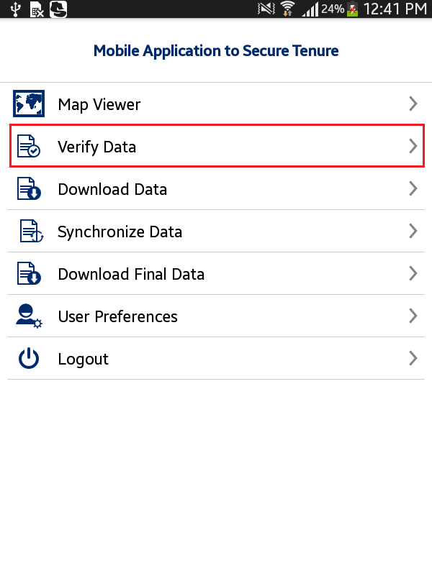Steps:**

1. ‘Adjudicator’ user logs in into the application
2. Application will open up homepage of application.
3. Following functionalities are visible:
   * + Map Viewer
     + Verify Data
     + Download Data
     + Synchronize Data
     + Download Final Data
     + User Preferences
     + Logout
4. User clicks on ‘Verify Data’ option available in homepage
5. 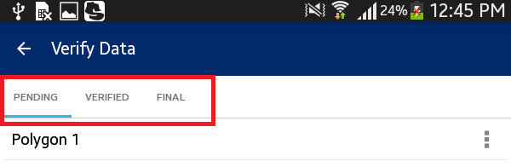Verify Data form will be displayed with following lists
   * + Pending
     + Verified
     + Final

# Pending

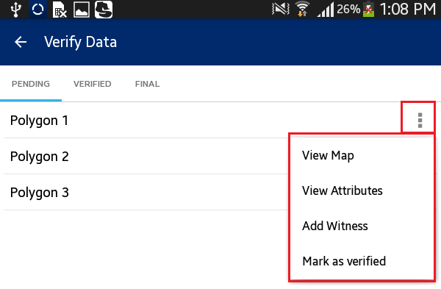‘Pending’ list display all the parcels that are pending to be verified by user. Following actions can be performed on a parcel which is in pending list.

* + - View Map
    - View Attributes
    - Mark as Verified

**Steps:**

1. Click on ‘Action’ option available with parcel record in ‘Pending’ list
2. List of available possible actions will be displayed
   * + View Map
     + View Attributes
     + Mark as Verified

## View Map

‘View Map’ facilitate user to perform editing on spatial data.

**Steps:**

1. Click on ‘View Map’ option

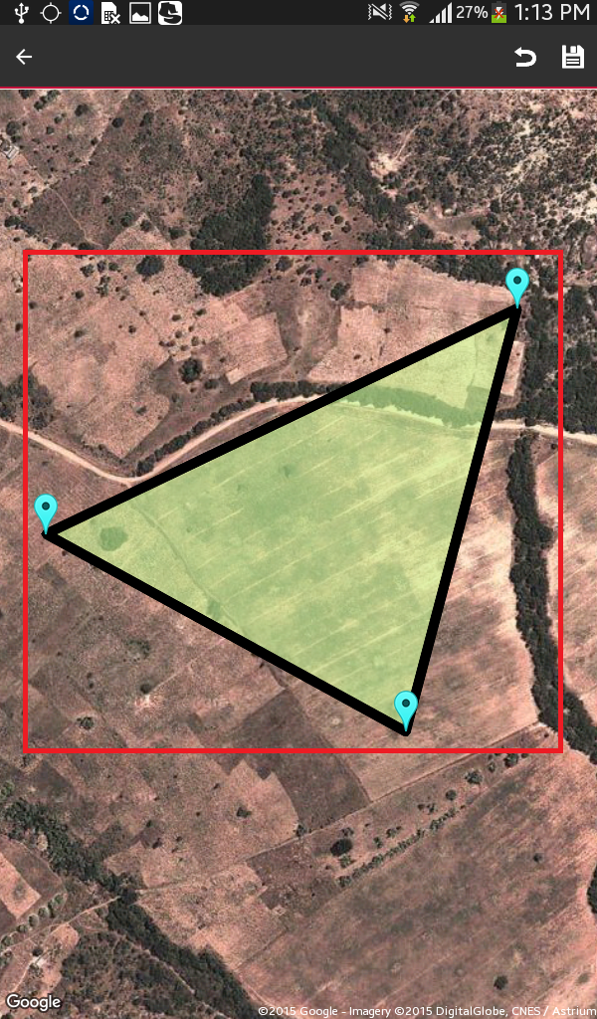

1. User will navigate to map and corresponding feature will be available in edit mode
2. Select node/vertices by long pressing the node/vertices and Edit the same
3. Click on ‘Save’ option
4. Application will save updated spatial feature

**Note: In case feature is not visible, click on back arrow button on left hand top of screen. Click on Capture Spatial data icon. Application will open up Layer Manager. Switch on Captured Features layer.**

## View Attributes

‘View Attributes’ facilitate user to view attribute data of spatial unit.

**Steps:**

1. 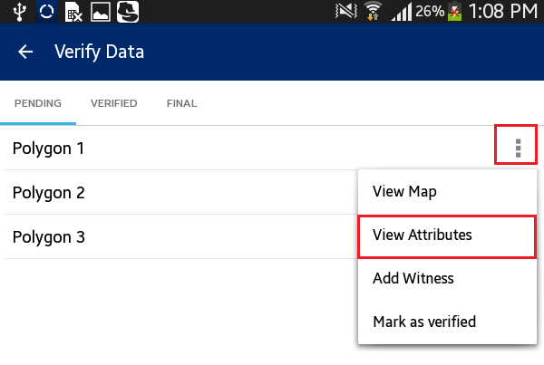Click on ‘View Attributes’ option
2. 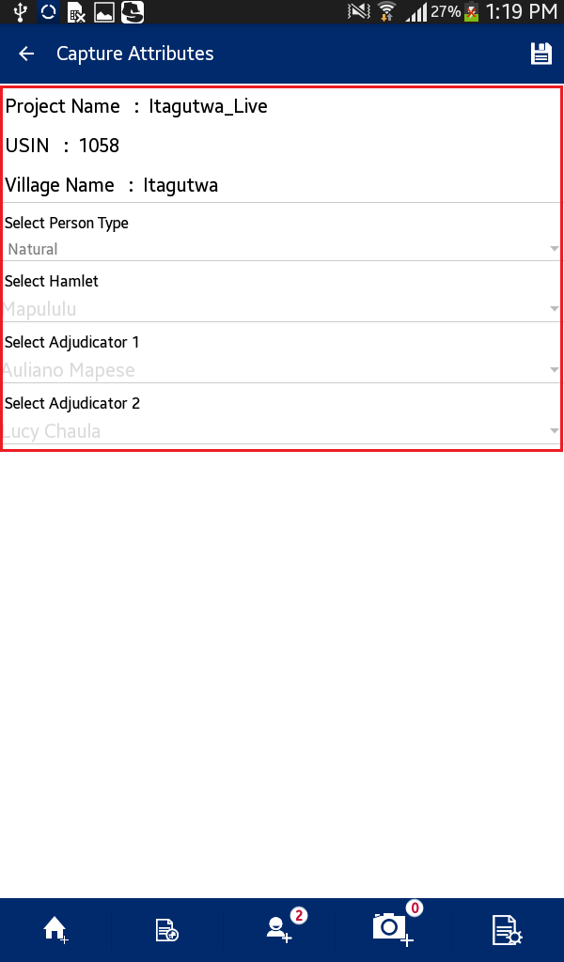User will navigate to ‘Capture Attributes' form and Attributes of corresponding feature will be available in read-only mode

## Mark as Verified

This functionality facilitate user to mark a parcel as Verified.

**Steps:**

1. 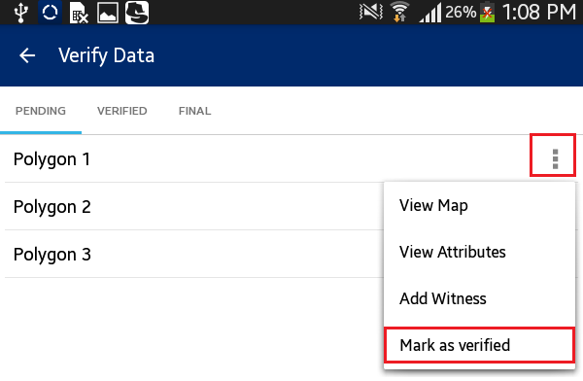Click on ‘Mark as Verified’ option
2. 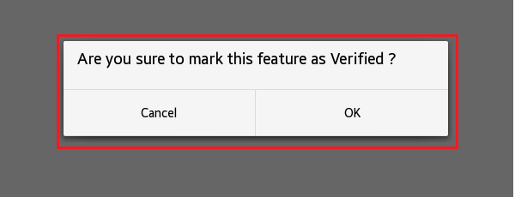Application will display a confirmation message along with ‘Cancel’ and ‘OK’ button
3. Click on OK button
4. 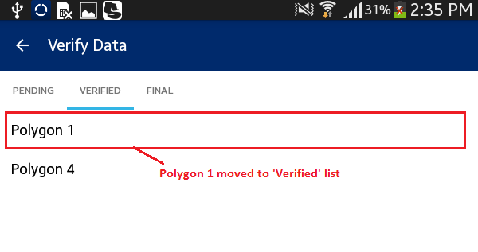Parcel will be verified. It will be removed from ‘Pending’ List and will become available in ‘Verified’ List

# Verified

‘Verified’ list display all the parcels that have been marked as verified, by user.

**Steps:**

1. ‘Adjudicator’ user logs in into the application
2. Application will open up homepage of application
3. User clicks on ‘Verify Data’ option available in homepage
4. Tap the device
5. 'Verified list' will be displayed

# Final

‘Final’ list display all the parcels that have been marked as final in web application.

**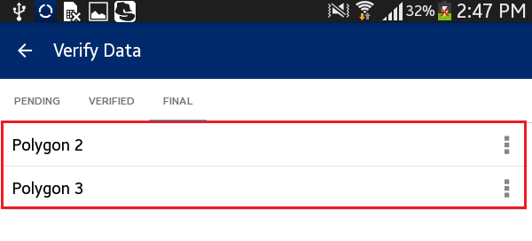Steps:**

1. ‘Adjudicator’ user logs in into the application
2. Application will open up homepage of application
3. User clicks on ‘Verify Data’ option available in homepage
4. Tap the device
5. 'Final list' will be displayed
6. Click on ‘Action’ option available with parcel record in ‘Final’ list
7. 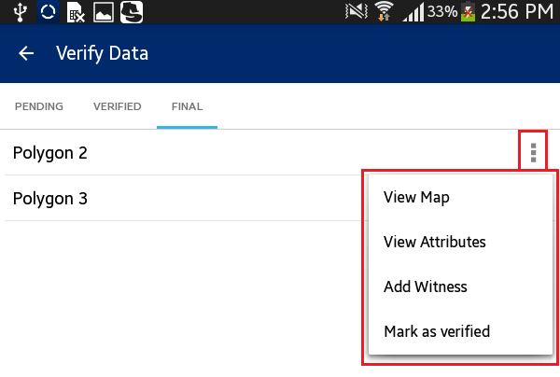List of available possible actions will be displayed
   * + View Map
     + View Attributes
     + Mark as Verified
8. Capture Data

This functionality will allow authorized user/s to Capture Spatial Data of parcels on map. This functionality provides users to Capture New Data (Point, Line and Polygon), Edit Data (Attribute and GIS data), Delete Data, Measure and view Info of selected feature.

**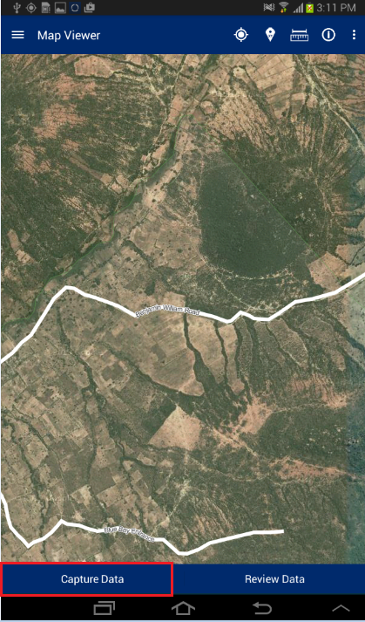Steps:**

1. User will click on ‘Capture Data’ button available in Map Viewer

**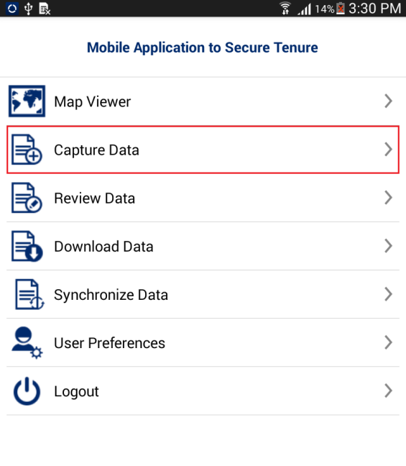Note: User can navigate directly to ‘Capture Data’ functionality by clicking on ‘Capture Data’ option available in homepage.**

1. 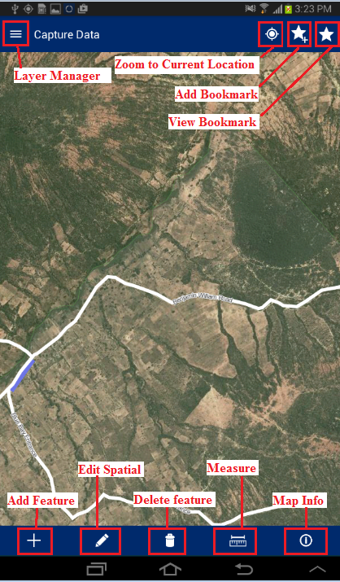 Application will open ‘Capture Data’ window. Following tools are available with ‘Capture Data’ window
   * + Layer Manager
     + Zoom to Current Location
     + Add Bookmark
     + View Bookmark
     + Add Feature
     + Edit Spatial
     + Delete Feature
     + Measure Tool
     + Map Info

# Layer Manager

This functionality provides the listing of layers configured for the selected project. User can On/Off display of a particular layer from the Layer Manager to view on the map.

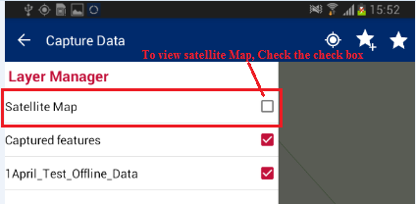**Steps:**

1. User click On Layer Manager option available on Top Left
2. 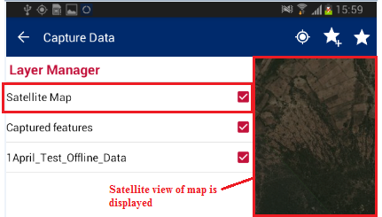Check the ‘Checkbox’ associated with layer
3. Selected Layer will become visible on map

# Zoom to Current Location

This functionality facilitates user to navigate to the map on current location.

**Steps:**

1. 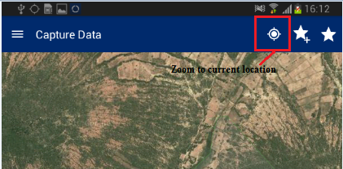User tap on ‘Zoom to current location' option available on top right
2. 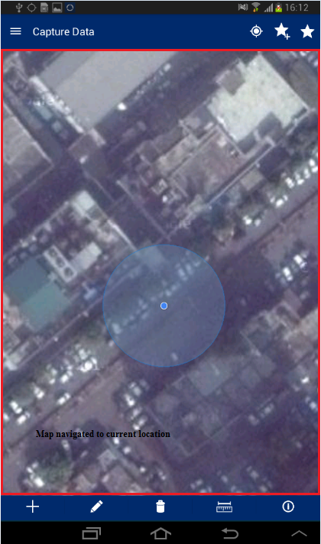Map will navigate to the current location

# Add Bookmark

Bookmarks tool facilitate users to save a particular area of interest of map canvas to save for future reference.

**Steps:**

1. 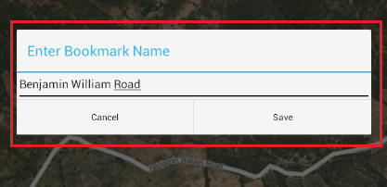User tap on ‘Add Bookmark’ option available on top right
2. ‘Enter Bookmark Name’ dialogue box will be displayed
3. Enter desired name in input box and click on ‘Save’ button
4. Bookmark will be saved with entered name and will become available in ‘Select Bookmark’ dialogue

# View Bookmark

This functionality facilitates user to navigate a selected bookmark.

**Steps:**

1. 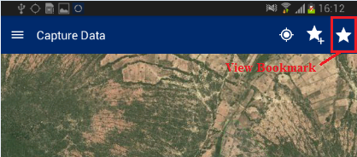User tap on ‘View Bookmarks’ option available on top right
2. 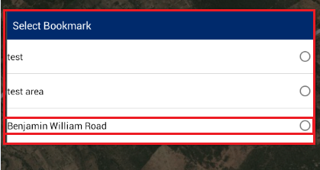‘Select Bookmark’ dialogue box will be displayed with list of all bookmarks available.
3. Select required bookmark
4. Map will navigate to the location saved with selected bookmark

# Add Feature

This functionality provides multiple tools to capture spatial data on map. These tools are point, line, and polygon. These features can be created ‘manual drawing’ or via GPS.

**Steps:**

1. 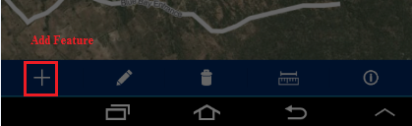User tap on ‘Add Feature’ option available on bottom tool box
2. 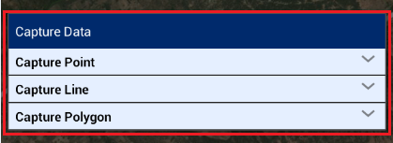‘Capture Data’ dialogue box will be displayed with following options
   * + Capture Point
     + Capture Line
     + Capture Polygon

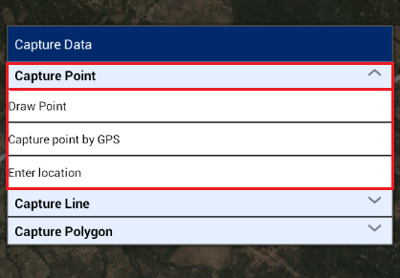

## Capture Point

‘Capture Point’ option facilitate user to capture point on map. User can capture a point manually, using GPS or by entering location coordinates.

**Steps:**

1. Tap the option ‘Capture Point’
2. Following options will be displayed
   * + Draw Point
     + Capture point by GPS
     + Enter Location

### Draw Point

This facilitate user to draw a point on map manually by clicking on required location on map.

1. 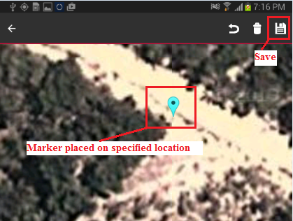Select the option ‘Draw Point’
2. Click on map
3. Marker will be placed on specified location
4. Click on Save option available on top right
5. Point placed on map will be saved and ‘Capture Attribute’ form will be displayed

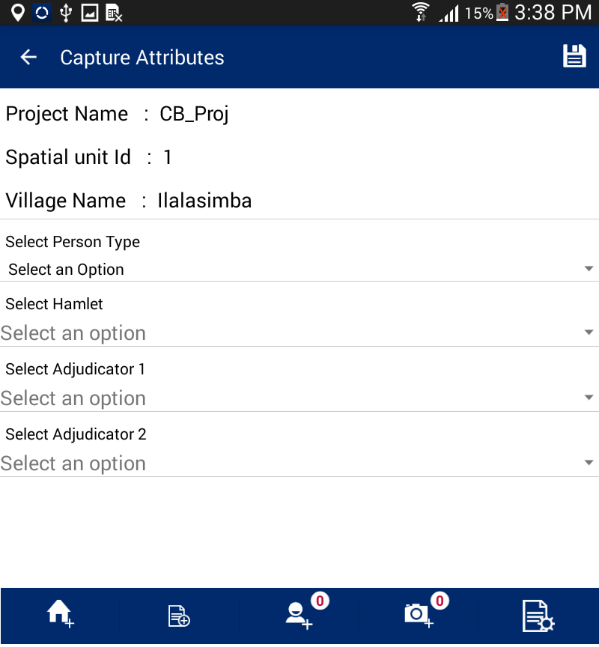

### Capture point by GPS

This facilitate user to draw a point on current location using GPS. Pre-requisite: GPS should be enabled on the device.

1. 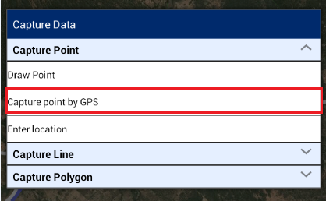Select the option ‘Capture point by GPS’
2. Click on ‘Plot point by GPS’ option available on top left
3. Marker will be placed on current location using GPS
4. Click on Save option available on top right
5. Point placed on map will be saved and ‘Capture Attribute’ form will be displayed

### Enter Location

This facilitate user to draw a point on location specified by entered coordinates.

1. 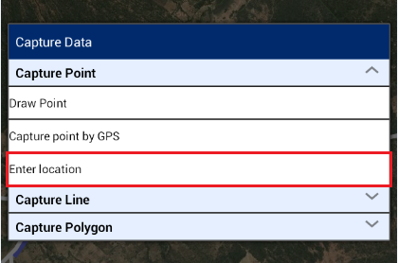Select the option ‘Enter Location’
2. Co-ordinate from map dialogue will be displayed
3. Enter coordinate values like X as 35.521124, Y as -7.743804
4. 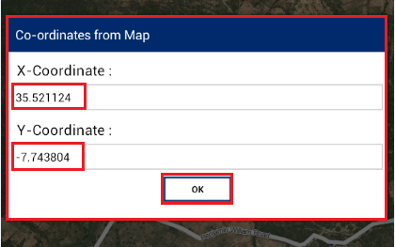Click on OK button
5. Marker will be placed on specified co-ordinates
6. Click on Save option available on top right
7. 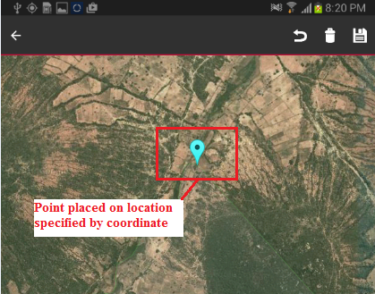Point placed on map will be saved and ‘Capture Attribute’ form will be displayed.

## Capture Line

**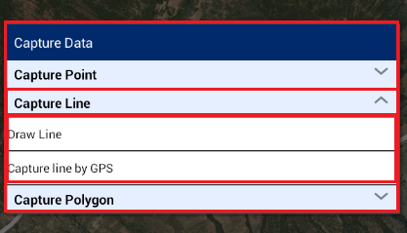**‘Capture Line’ option facilitate user to capture line on map. User can capture a line manually by clicking on map or using GPS.

**Steps:**

1. Tap the option ‘Capture Line’
2. Following options will be displayed
   * + Draw Line
     + Capture Line by GPS

### Draw Line

This facilitate user to draw a Line on map manually by clicking on required locations on map.

1. Select the option ‘Draw Point’
2. 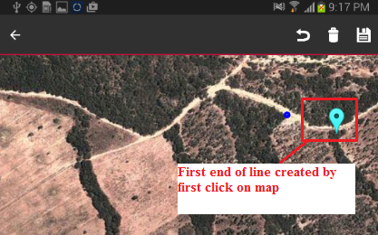Click on map, On first click, first end of line will be created
3. Subsequently, click on second or more locations on map to create second end of line
4. 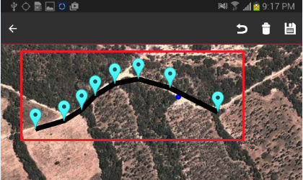Markers will be placed on clicked locations and line will be created
5. Click on Save option available on top right
6. Line placed on map will be saved and ‘Capture Attribute’ form will be displayed

### Capture Line by GPS

This facilitate user to draw a point on current location using GPS.

1. 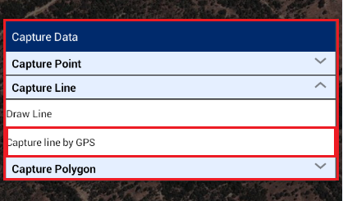Select the option ‘Capture line by GPS’
2. Click on ‘Plot point by GPS’ option available on top left
3. Marker will be placed on current location using GPS
4. Move the device to second location and click on ‘Plot point by GPS’
5. Marker on other location will be placed on current location using GPS
6. Click on Save option available on top right
7. Line placed on map will be saved and ‘Capture Attribute’ form will be displayed

## Capture Polygon

**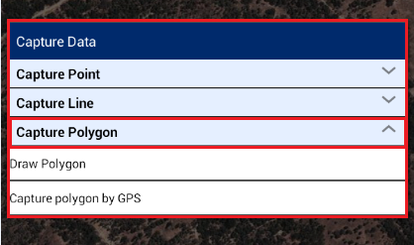**‘Capture Polygon’ option facilitate user to capture polygon on map. User can capture a polygon manually by clicking on map or using GPS.

**Steps:**

1. Tap the option ‘Capture Polygon’
2. Following options will be displayed
   * + Draw Polygon
     + Capture Polygon by GPS

### Draw Polygon

This facilitate user to draw a Polygon on map manually by clicking on required locations on map.

1. 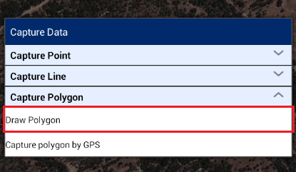Select the option ‘Draw Polygon’
2. Click on map, On first click, first vertex of polygon will be created
3. Subsequently, click on second, third or more locations on map to create polygon
4. Markers will be placed on clicked locations and polygon will be created
5. Click on Save option available on top right
6. 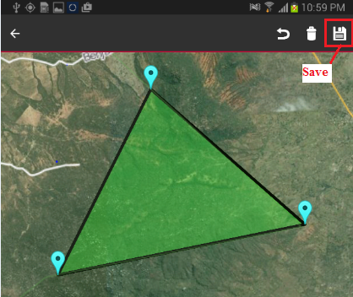Polygon placed on map will be saved and ‘Capture Attribute’ form will be displayed

### Capture Polygon by GPS

This facilitate user to draw a Polygon covering current locations using GPS.

1. 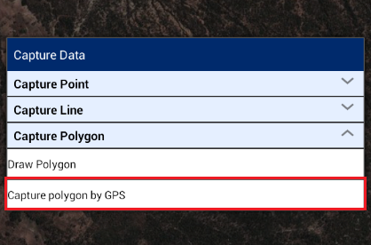Select the option ‘Capture Polygon by GPS’
2. Click on ‘Plot point by GPS’ option available on top left
3. Marker will be placed on current location using GPS
4. Move the device to second location and click on ‘Plot point by GPS’
5. Marker on second location will be placed on current location using GPS
6. Move the device to third or more locations and click on ‘Plot point by GPS’
7. Marker will be placed on current location using GPS and polygon will be created
8. Click on Save option available on top right
9. 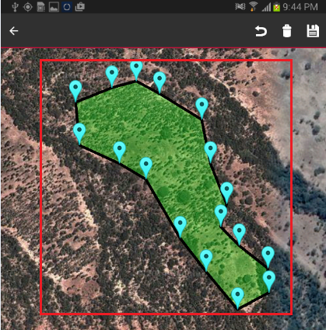Polygon placed on map will be saved and ‘Capture Attribute’ form will be displayed

# Capture Attribute

Once any Spatial Data (Line, Point or Polygon) is captured on map, User will be facilitated to capture attribute and multimedia data for the spatial unit. Attributes that will be captured are configurable by mobile configuration tool of web application.

**Steps:**

1. After the creation of spatial data, a User clicks on ‘Save’ option available on top left of screen.
2. 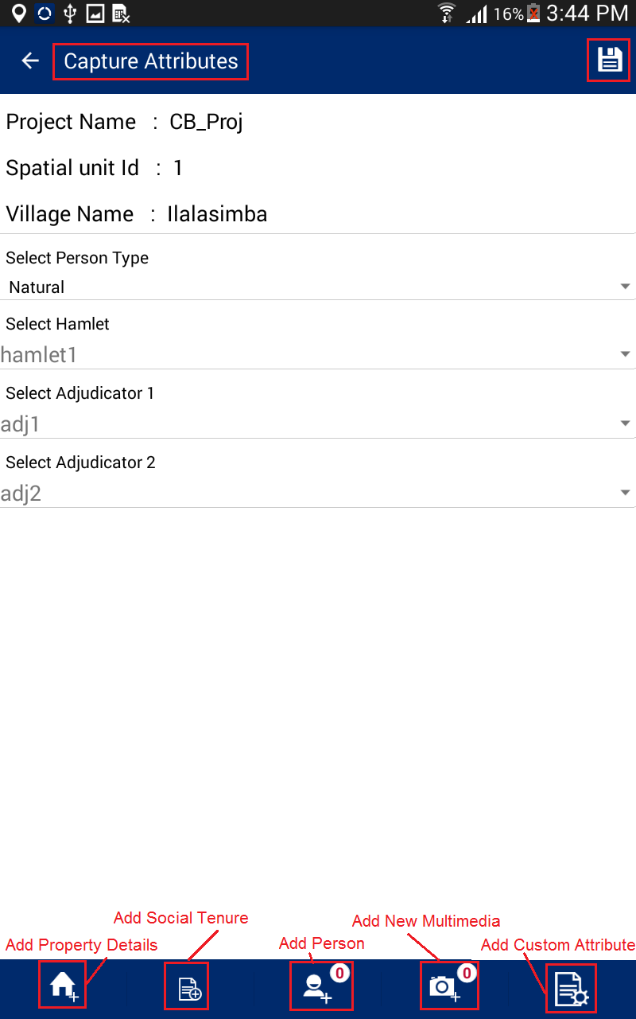The Application will save the spatial data and ‘Capture Attributes’ form will be displayed with following options :
3. Select Person Type
4. Select Hamlet
5. Select Adjudicator 1
6. Select Adjudicator 2

This form will be the general category, which the user will select the type of person, location, and witnesses. Enter general information and Click on ‘Save’ option. The application will save the general information and ‘Add Property’ screen will be shown.

The Application facilitates user with following options:

* Add property
* Add Social Tenure
* Add Person
* Add New Multimedia
* Add Custom Attribute

1. 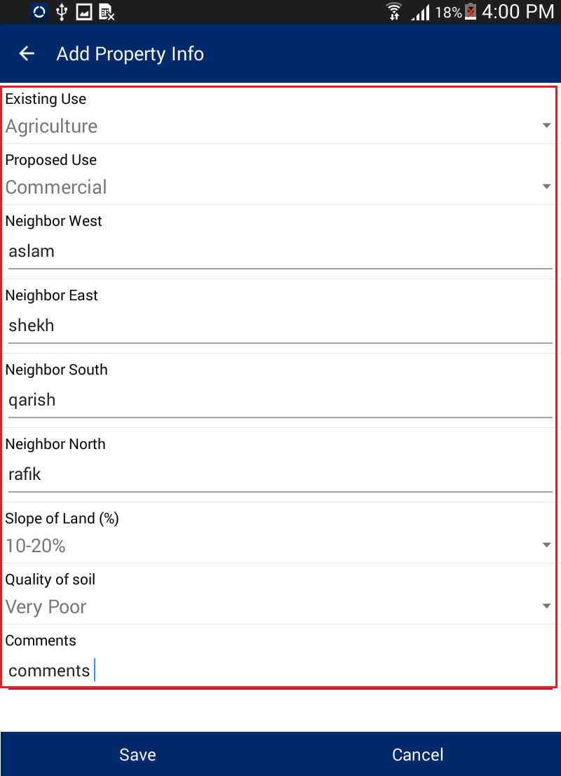Details will be saved and user will navigate to ‘Add Property Info’ from.

In the Property Screen, the user will be prompted to enter the required property details. Once the data is entered, the user will then click on the ‘Save’ option. The application will save the property information and ‘Social Tenure’ screen will be shown.

1. In the Social Tenure Screen, the user will enter required details and click on ‘Save’ button. The application will save the social tenure information and ‘Person Listing’ screen will be shown.

Note: - As per the selection of person type in Capture Attributes, user will be able to select type of tenure in Add Social tenure form.

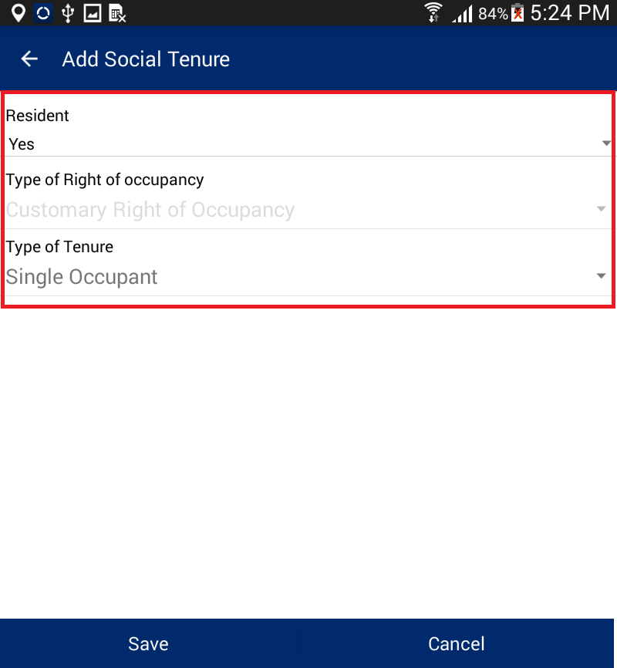In social tenure user selects details like Resident, Type of Tenure and Type of Right of Occupancy. As per the selection of type of tenure Add Person form displays.

There are five “Type of Tenure” for Natural Person. These are:

Multiple Occupancy (Tenancy in Common)

Single Occupant

Multiple occupancy (Joint Tenancy)

Tenancy in probate (Administrator)

Guardian (Minor)

* **Multiple Occupancy (Tenancy in Common):** If user selects this tenure type and saves the form, then the user will be prompted to add users in the Add Person form. The user will be required to add two or more “*Owners*” and there can add one or more “*Person(s) of Interest*”.

**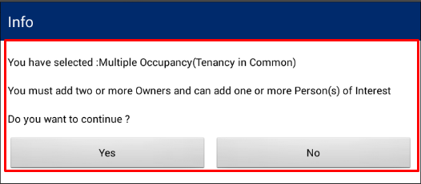**

* **Single Occupant:** If user selects this type of tenure, and saves the form, then the user will be prompted to add users in the Add Person form. In this case, the user will be required to add only one “*Owner*” and will have the possibility to add one or more “*Person(s) of Interest*”.

**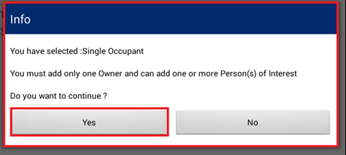**

* **Multiple Occupancy (Joint Tenancy) :** If user selects that tenure type, he or she will be prompted to add users in the Add Person form. In the add person form, the user will be required to add two “*Owners*” and may add one or more “*Person(s) of Interest.*”

**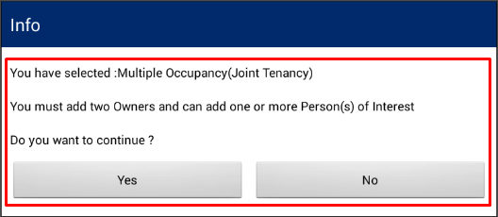**

* **Tenancy in probate (Administrator):** If user selects that tenure, then in Add Person form he or she will be required to add one or more “*Owner(s)*”. Based on the tenure selection, the user may and up to two “*Administrators*” and will also need to indicate the name of the “*Deceased Person*”. The user can also add one or more “*Person(s) of Interest*.”

**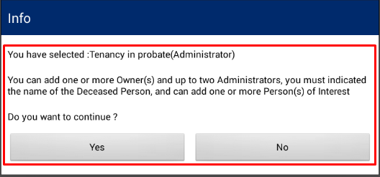**

* **Guardian (Minor):** If user selects this tenure type, then the user will be prompted to add users in the Add Person form. The user will be required to add one or more “*Minor*” and up to two “*Guardian*”.

**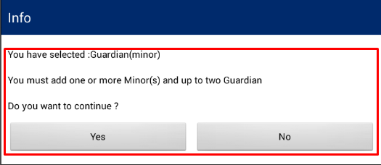**

***Note:- It is mandatory to add photo for Owner, Administrator and Guardian.***

Based on tenure type the user has selected, the user will be required to provide inputs available in ‘Add Person’ from, Click on ‘Save’ button.

1. 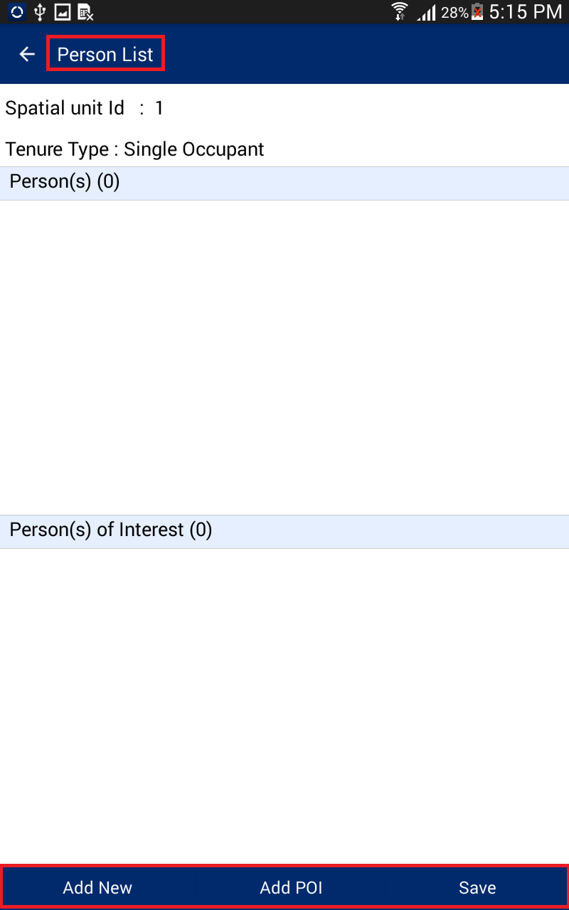Click on ‘Yes’ button available on displayed message box, User will be navigated to ‘Person List form’.
2. Click on ‘Add New’ button, ‘Person Sub-type’ dialogue will be displayed, Select the required radio button, click on Save button.

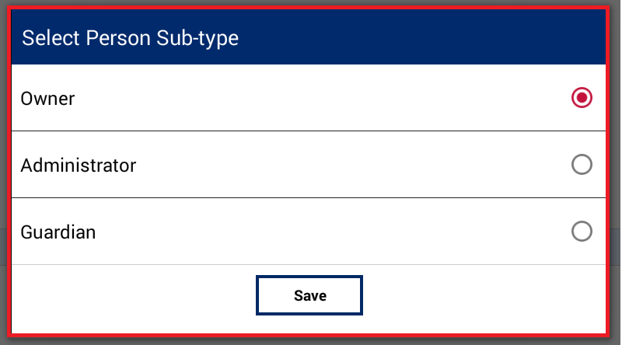

1. ‘Add Person’ form will be displayed. User will enter the desired attributes and and click on ‘Save’ button.
2. **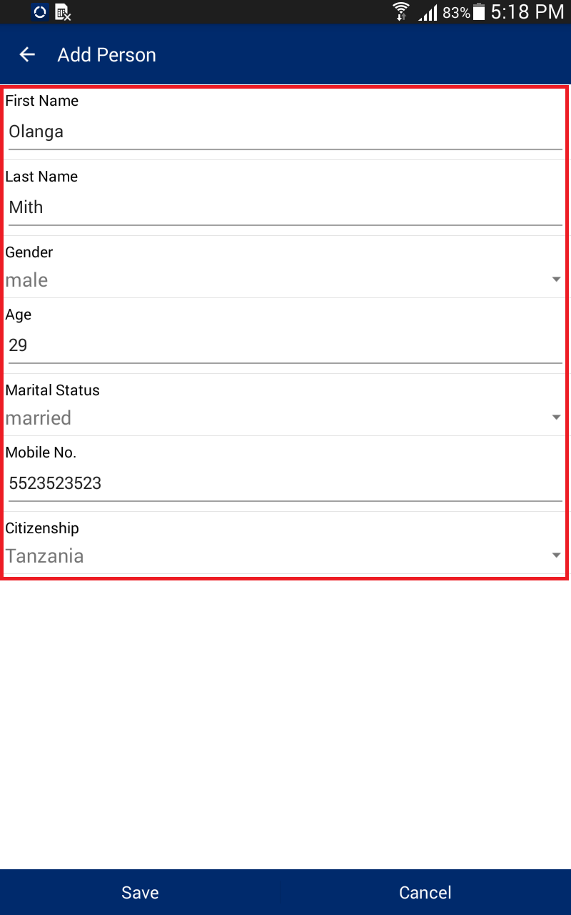**Personal details will be saved and details will become available in corresponding section.

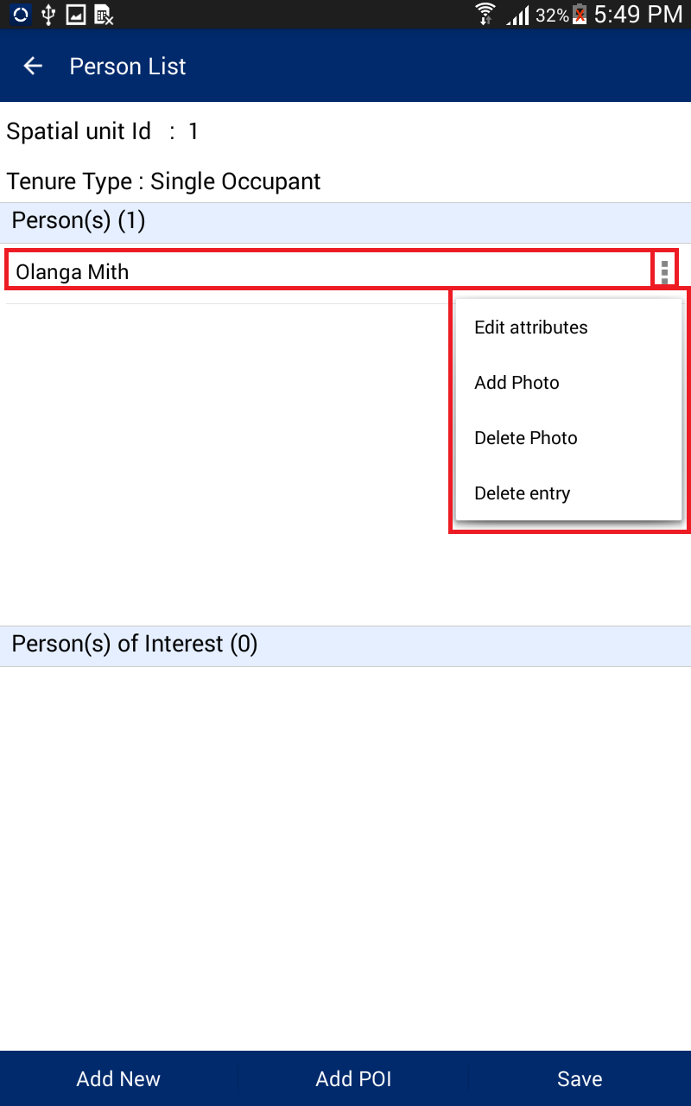

1. Click on option associated with record available in Person(s) section, following options will be available.

* Edit Attribute
* Add Photo
* Delete Photo
* Delete entry

**Note:**

* **Edit Attribute:** Edit Attribute’ option will enable user to edit the current details of person.
* **Add Photo:** ‘Add Photo’ will enable user to take the snap of person and associate it with details.
* **Delete Photo:** ‘Delete Photo’ will enable the user to delete existing photo.
* **Delete entry:** ‘Delete Entry’ will enable user to delete person details.

1. Click on ‘Add POI’ button. ‘Add Person of Interest’ dialogue will be displayed. Provide the required details and click on ‘Save’ button.

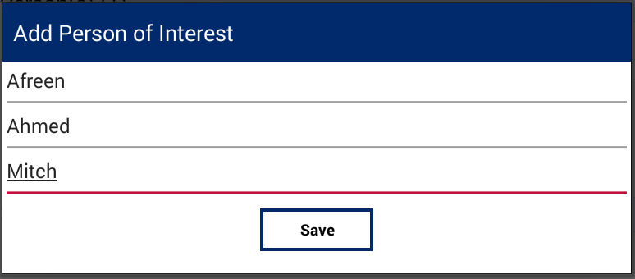

Note: for person of interest, only the first, middle and last name are required.

1. Details of ‘Person of Interest’ will be saved and details will become available in corresponding section.
2. 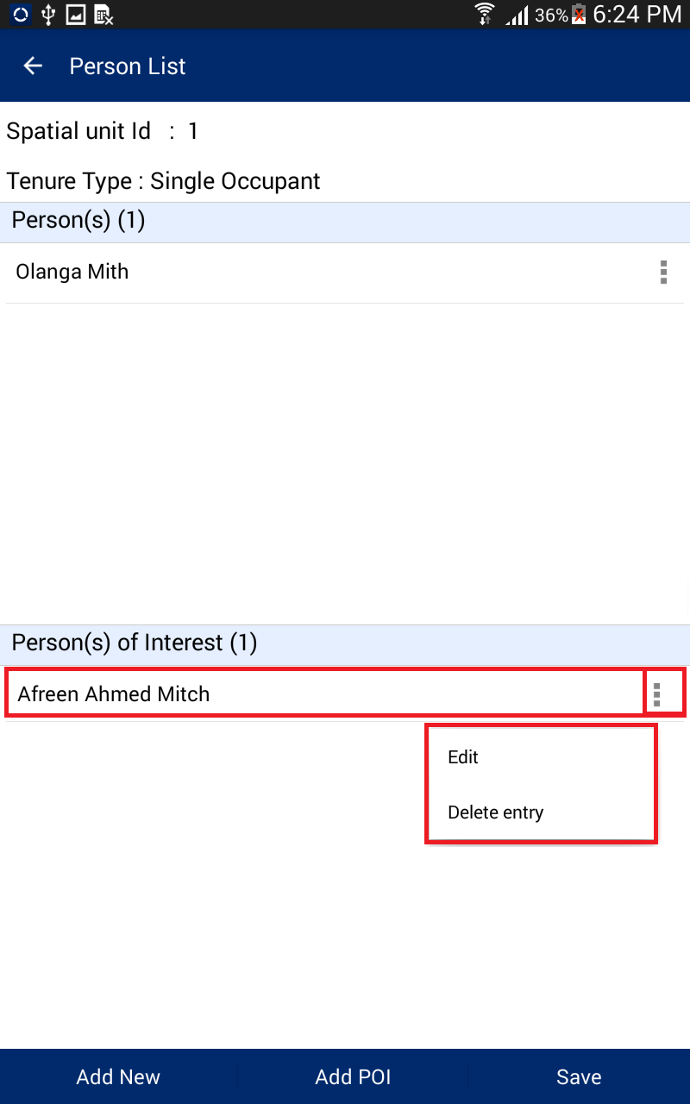Click on option associated with record available in ‘Person(s) of Interest’ section, following options will be available.

* Edit
* Delete Entry

**Note:**

* **Edit:** ‘Edit’ option will enable user to edit the current details of person of interest.
* **Delete entry:** ‘Delete Entry’ will enable user to delete person details.

1. Once required details are added, click on ‘Save’ button. ‘Collected Data Summary’ page will be displayed with summary of date captured.

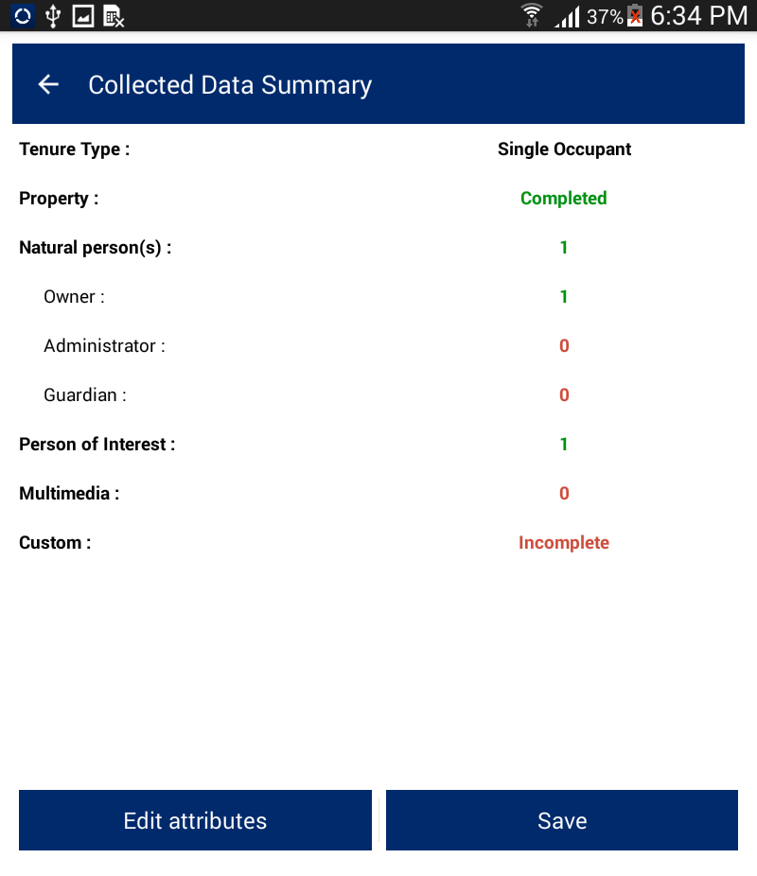

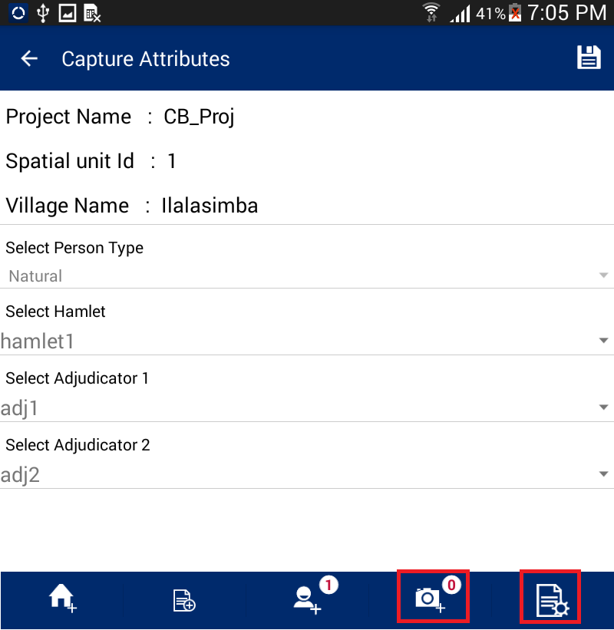If any of the details are incomplete, click on ‘Edit Attribute’ button, and the ‘Capture Attribute’ form will be displayed, Click on corresponding option available in bottom tool bar and complete the detail.

1. for instance, if the user desires to enter additional multi-media information, the user can click on on ‘Add New Multimedia’ option, ‘Multimedia List’ form will be displayed.
2. Click on ‘Add New’ button.

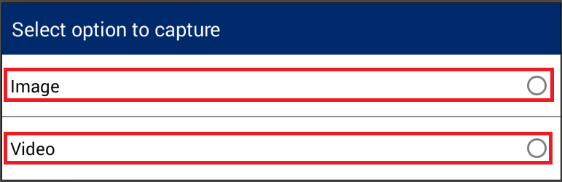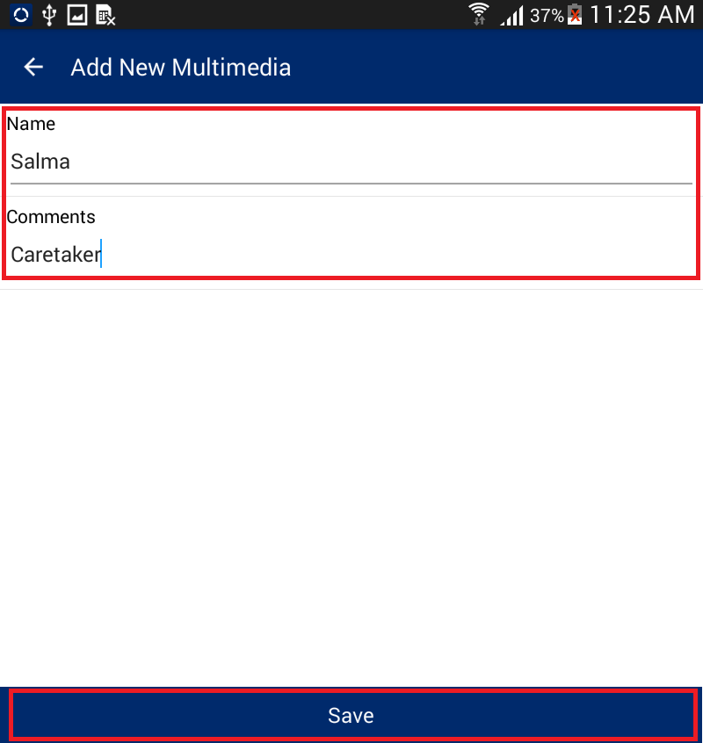

1. The select Multimedia' dialogue will be displayed, and the user can s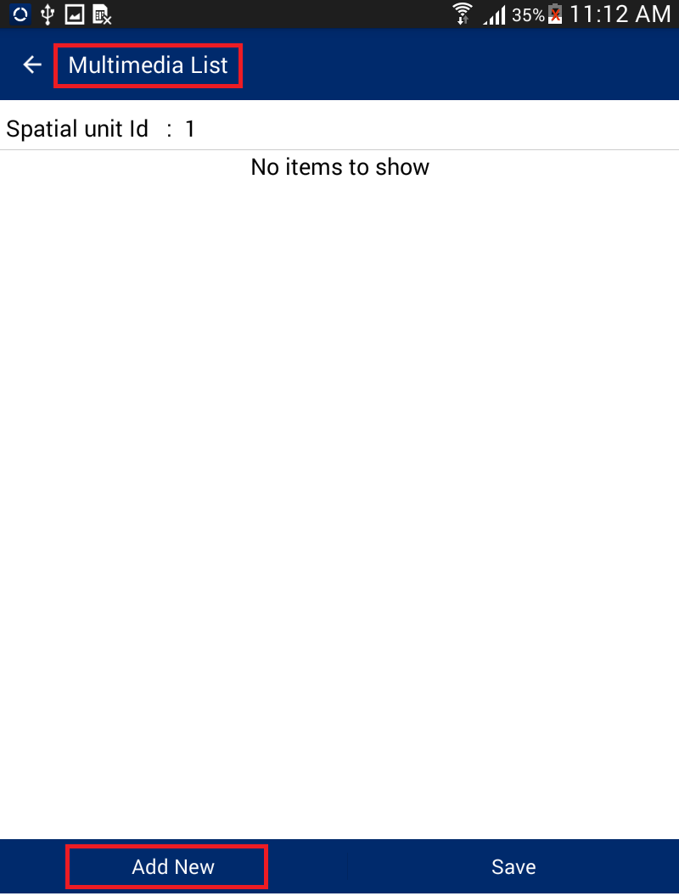elect Multimedia type, capture and save the same.
2. Once the multimedia file is created, the user can provide details. The 'Add New Multimedia' form will be displayed. Enter Details and click on ‘Save’ button.
3. Multimedia details will be saved and will be available in ‘Multimedia List’. Following options will be available with record.

* View Media
* Edit Attribute
* Delete Entry

**Note:**

* **View Media:** Enables user to view attached multimedia.
* **Edit Attribute:** Enables user to edit attributes associated with multimedia.
* **Delete Entry:** Enables user to delete multimedia and associated attributes.

1. 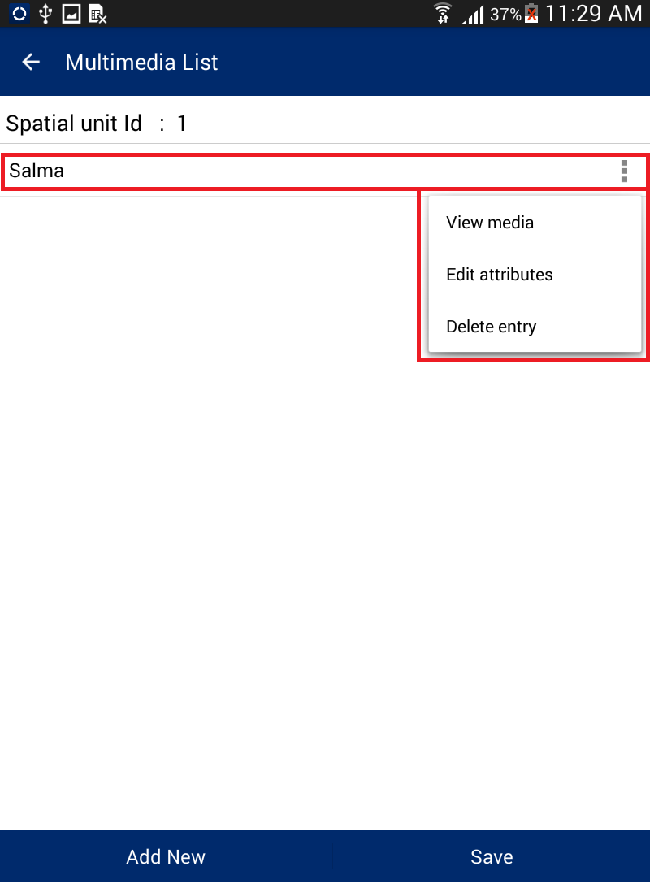Click on ‘Save’ button, ‘Collected Data Summary’ form will be displayed. Click on ‘Edit attributes’ button. Numbers of attached Multimedia will be available along with ‘Add New Multimedia’ Option.]

User can capture Image / Video. Once Image/Video is saved, same will get associated with parcel.

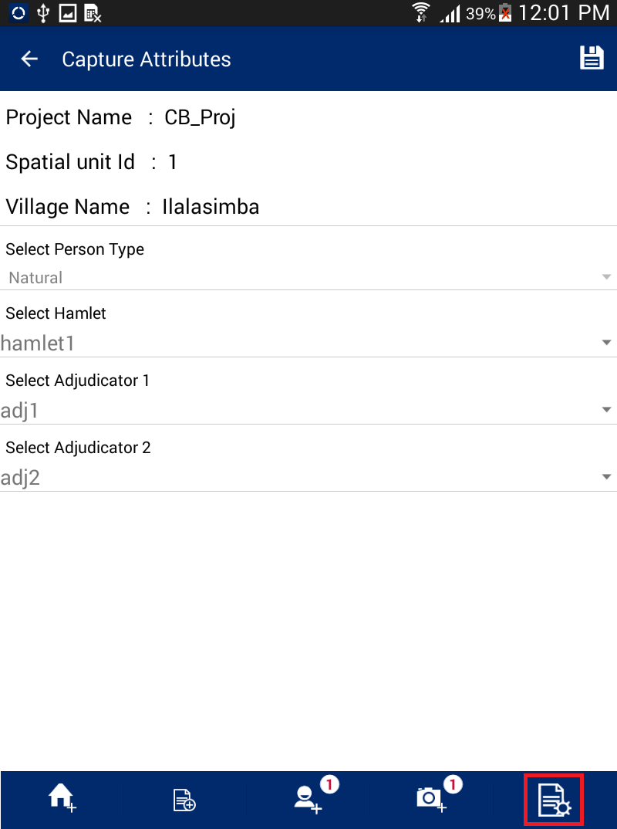Please note that custom attributes can be added to the mobile application through the configuration tool. If custom attributes have been added as part of the project, the user can have to option to fill in the desired attributes. To add custom attributes, the user may Click on ‘Add Custom Attributes’ option.

1. ‘Custom Attributes’ form will be displayed. Enter attribute Details and click on ‘Save’ button.
2. Custom attribute details will be saved.

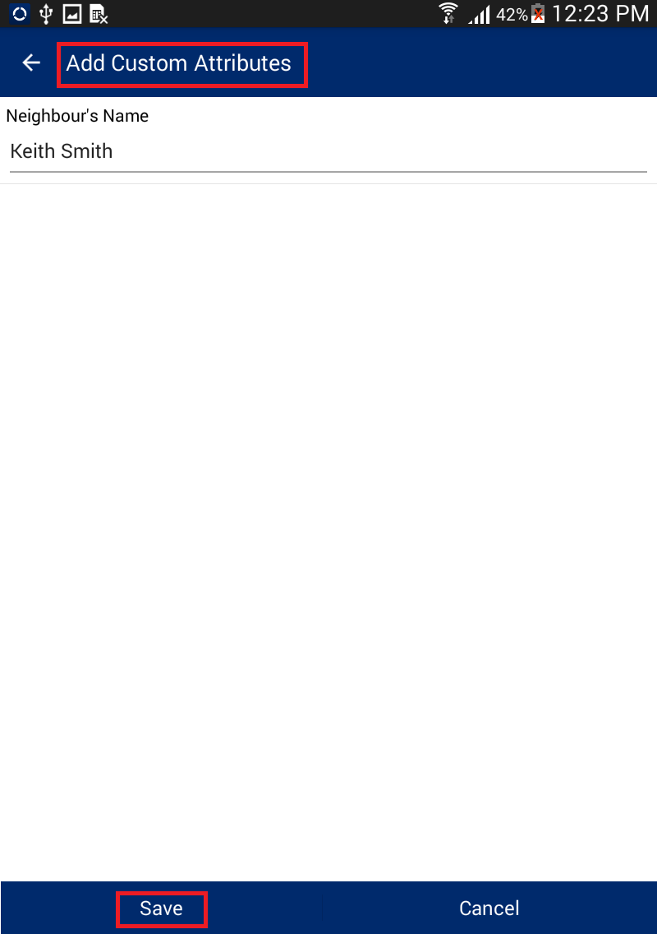

# Screenshot_2015-11-17-12-35-41.pngEdit Spatial

This functionality will allow user/s to edit spatial data which has already been captured by the user.

**Steps:**

1. Click on ‘Capture Data’ option available on home page.
2. 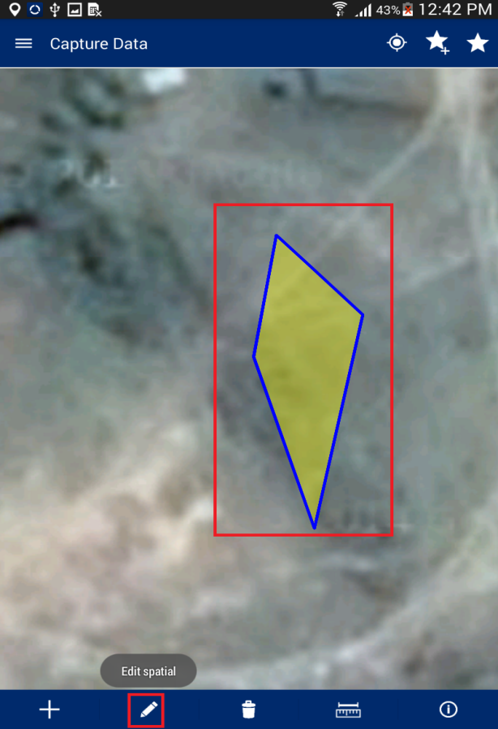Navigate to parcel which is to be edited.
3. Click on Edit Spatial data icon
4. Click on feature to be edited
5. 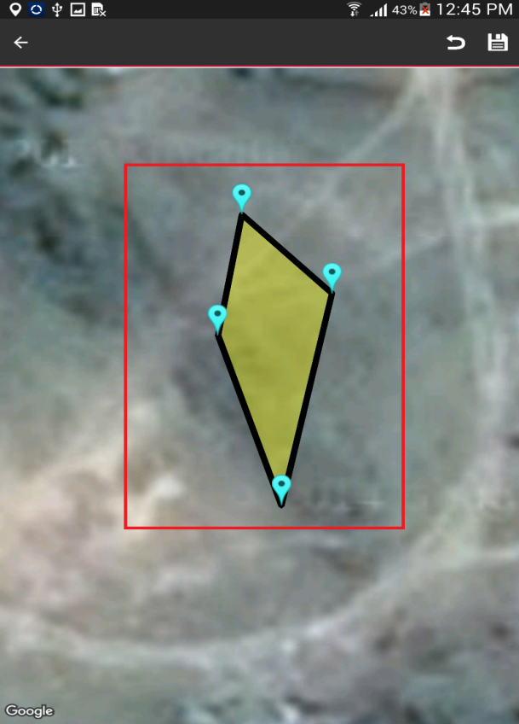Application will show nodes/vertices in editable format
6. 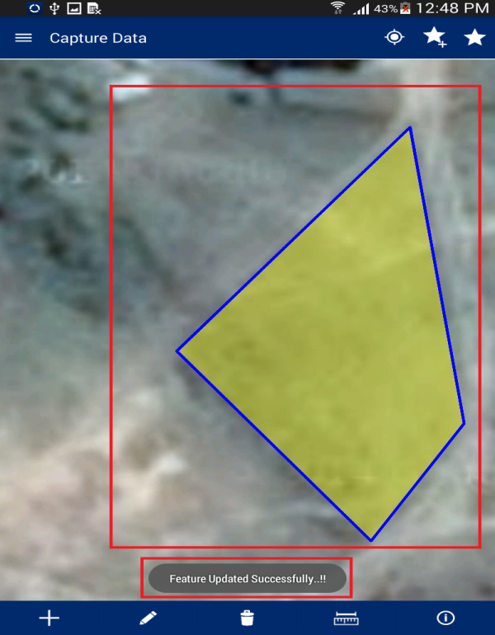User will select node/vertices by long pressing the node/vertices and move the same
7. User will click on save icon available on right top
8. Application will save updated spatial feature and an acknowledgement message will be displayed

**Note:** In case feature is not visible, click on back arrow button on left hand top of screen. Click on Capture Spatial data icon. Application will open up Layer Manager. Switch on Captured Features layer.

# Delete Feature

This functionality will allow user/s to delete spatial data.

**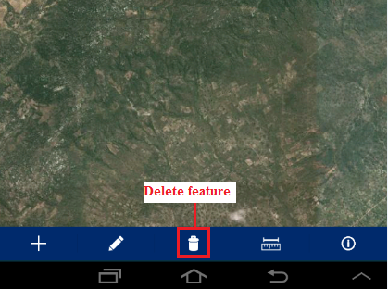Steps:**

1. Click on Delete icon

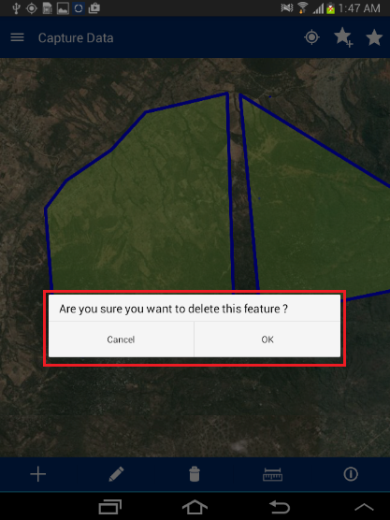

1. Click on created spatial feature
2. Application will show confirmation message to user “Are you sure you want to Delete this feature?” with ‘Ok’ and ‘Cancel’ option
3. Click on ‘Ok’ button
4. 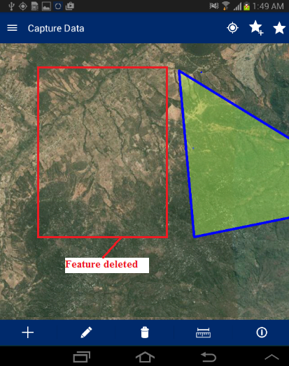Application will delete the selected feature and same will not be visible in the map

# Measure

This functionality facilitates user to measure the area of any polygon, Length on any line or the distance between two points on map.

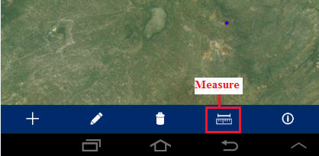**Steps:**

1. User tap on ‘Measure’ option available on bottom of ‘Capture Data’ tool
2. ‘Select feature to measure’ dialogue will be displayed with following options –
   * + Calculate Distance
     + Calculate Area
     + Measure Polygon Area
     + Measure Line Length

## Calculate Distance

This functionality facilitates user to calculate the distance between two or more subsequent points on map.

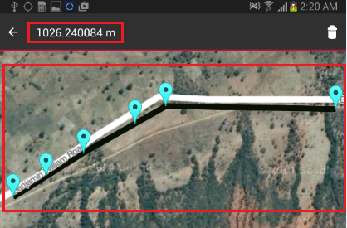**Steps:**

1. Tap on ‘Measure’ option available on top right
2. Select ‘Calculate distance’ option
3. Click on map to specify at least two points
4. Application will calculate Distance and display it on top right of application

## Calculate Area

This functionality facilitates user to calculate the area of polygon by specifying it on map.

**Steps:**

1. Tap on ‘Measure’ option available on top right
2. Select ‘Calculate Area’ option
3. Click on map to specify at least three points
4. Application will calculate Area and display it on top right of application

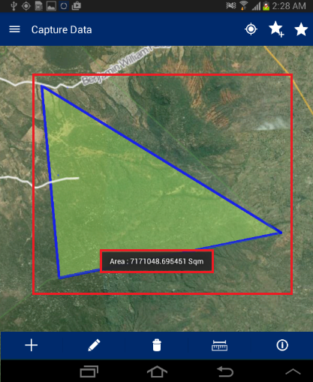

## Measure Polygon Area

This functionality facilitates user to calculate the area of existing polygon feature by specifying it on map.

**Steps:**

1. Tap on ‘Measure’ option available on top right
2. Select ‘Measure Polygon Area’ option
3. Click on existing polygon feature map
4. Application will calculate Area and display it on map only

## Measure Line Length

This functionality facilitates user to calculate the length of existing line feature by specifying it on map.

**Steps:**

1. Tap on ‘Measure’ option available on top right
2. Select ‘Measure Line Length’ option
3. Click on existing Line feature map
4. 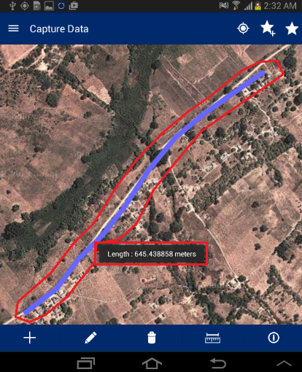Application will calculate Length and display it on map only

# Map Info Tool

This functionality facilitates user to View the attribute details of any spatial feature which is already created on map.

**Steps:**

1. Navigate to existing feature on map
2. Tap on ‘Map Info’ option available on bottom of Capture tool
3. Click on feature on map
4. 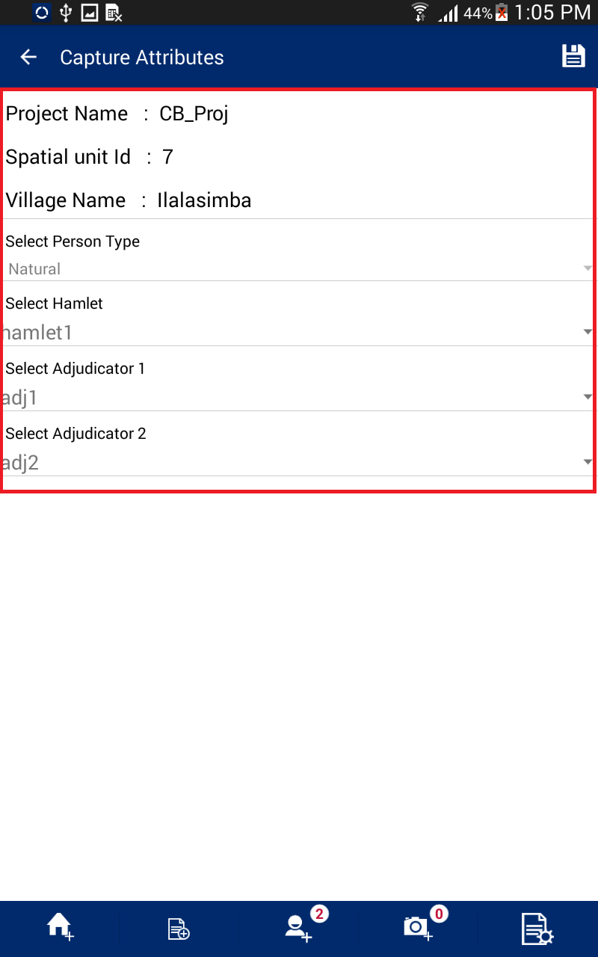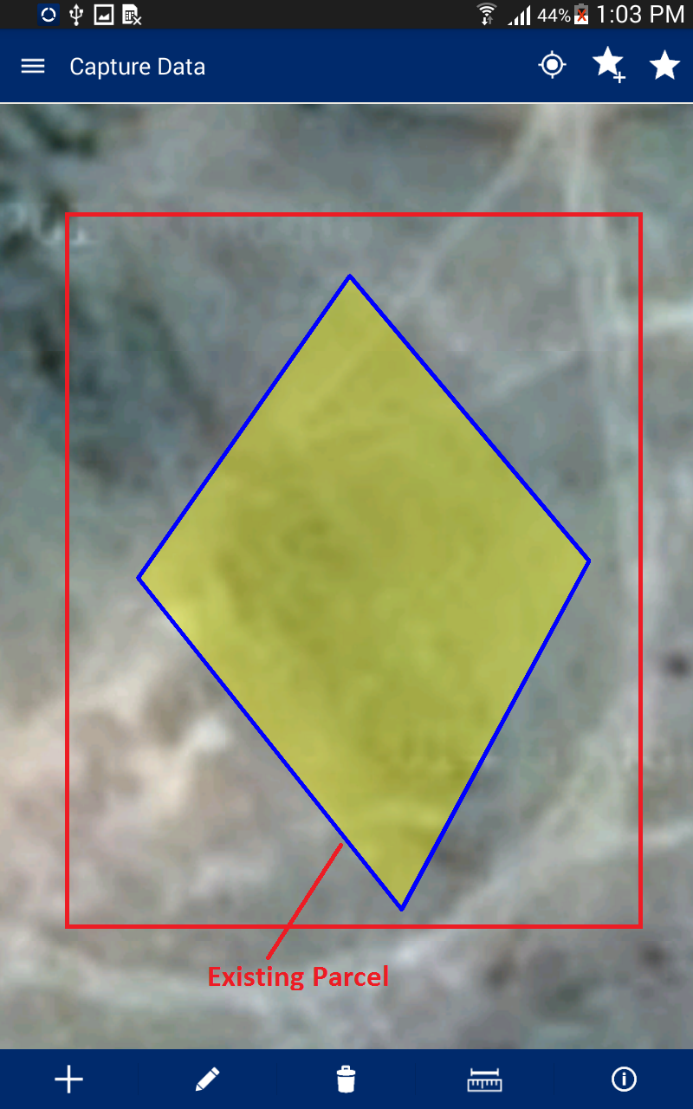Attribute details of specified feature will be displayed
5. Review Data

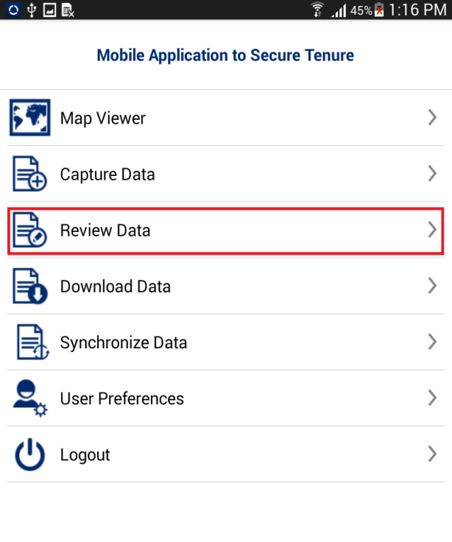This functionality facilitate user to view the data collected in field for review and finalization purpose. This also facilitate user to Edit Special, Edit Attribute, Delete Entry or mark a parcel as complete.

**Steps:**

1. Click on ‘Review Data‘ option available on Home page
2. 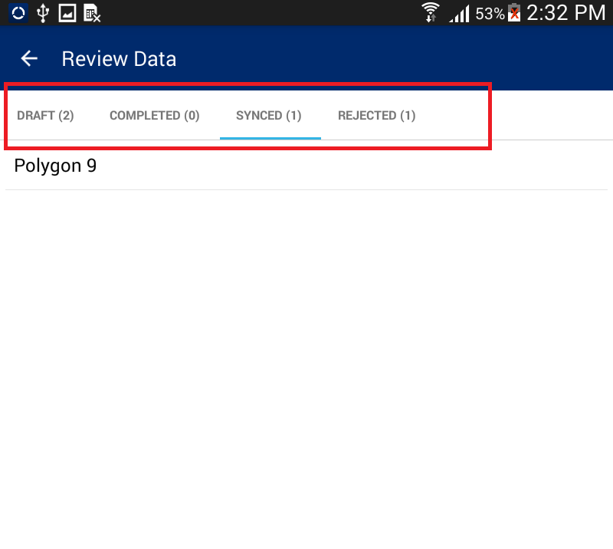 ‘Review Data’ form will be displayed with following lists
   * + **Draft –** Parcels that are not marked as complete will be listed in ‘Draft’ list
     + **Completed –** Parcel that are marked as complete will be listed in ‘Completed’ list
     + **Synced –** Parcels that has been synced will be listed in ‘Synced’ list
     + **Rejected –** Parcel that are rejected from Back end web application, will be listed in ‘Rejected’ list

# Draft List

Parcel that is not marked as completed will be listed in ‘Draft’ list. User can perform following actions on parcels available in Draft List.

* + - Edit Special
    - Edit Attribute
    - Delete Entry
    - Mark as Complete

**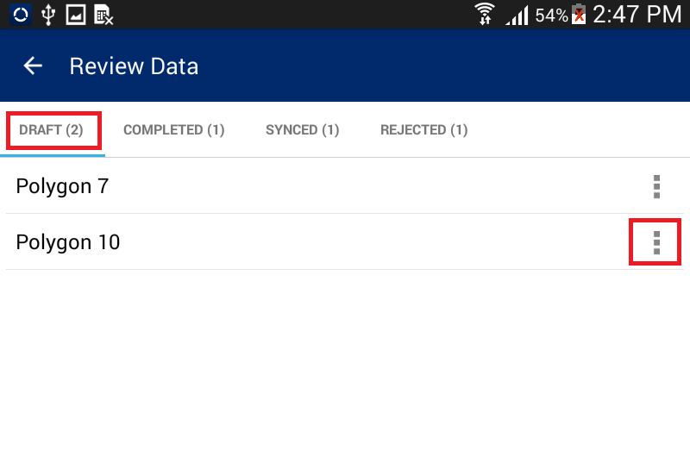Steps:**

1. Click on ‘Action’ option available with parcel record in ‘Draft List’
2. 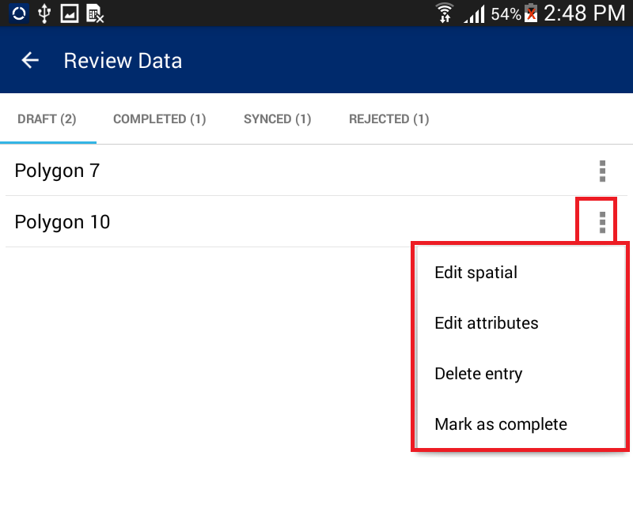List of available possible actions will be displayed

## Edit Spatial

‘Edit Spatial’ facilitate user to perform editing on spatial data.

**Steps:**

1. 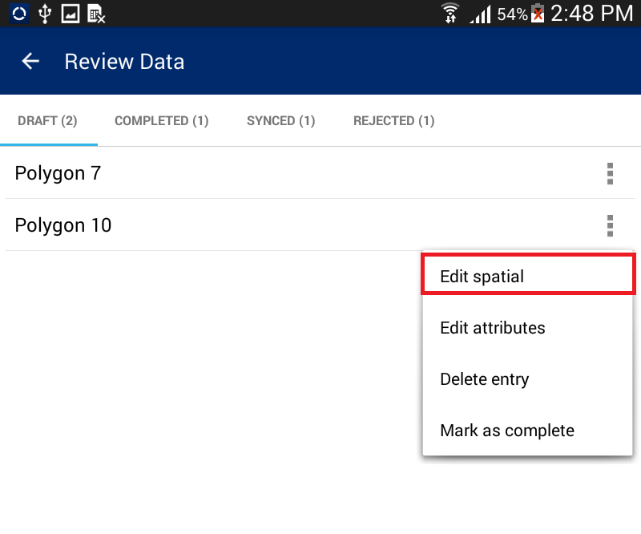Select ‘Edit Spatial’ option
2. 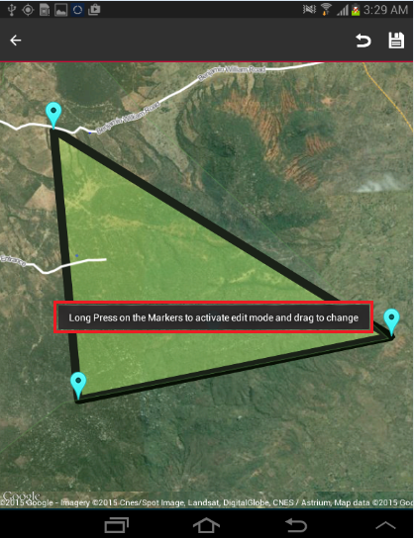User will navigate to Map and corresponding feature will be available in edit mode.
3. Select node/vertices by long pressing the node/vertices and move the same.
4. Click on ‘Save’ option
5. Application will save updated spatial feature.

**Note: In case feature is not visible, click on back arrow button on left hand top of screen. Click on Capture Spatial data icon. Application will open up Layer Manager. Switch on Captured Features layer.**

## Edit Attribute

‘Edit Attribute’ facilitate user to edit attribute data of spatial unit.

**Steps:**

1. 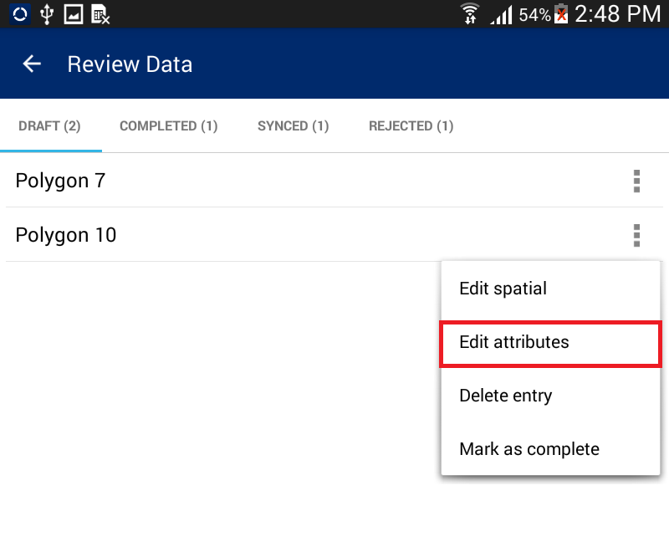Click on ‘Edit Attribute’ option

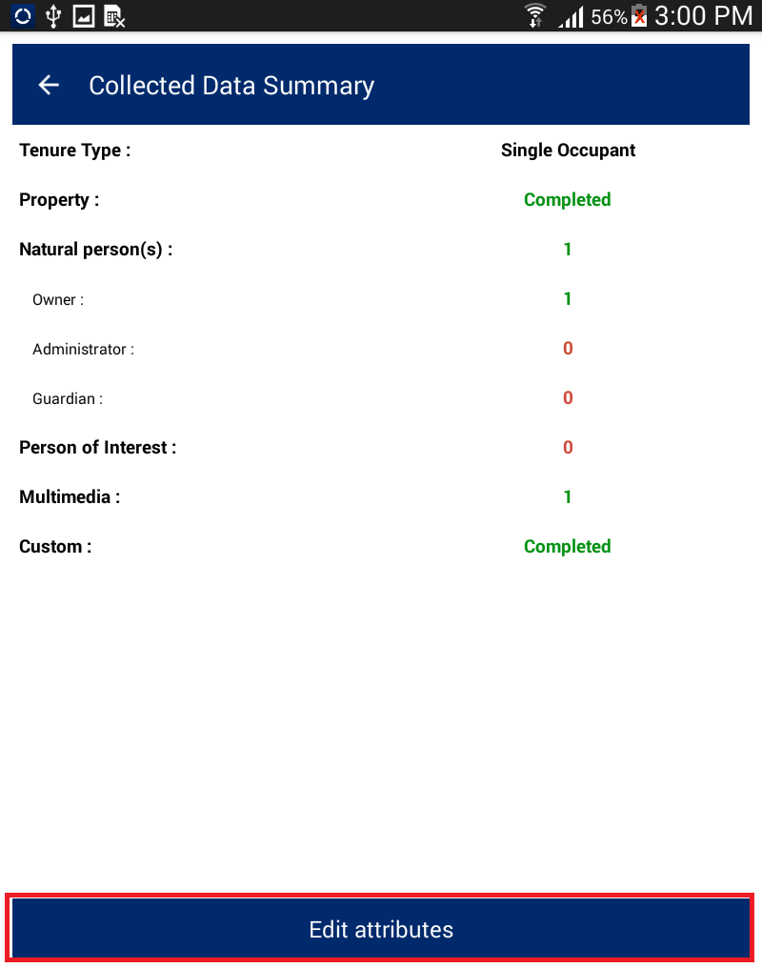

1. User will navigate to ‘Collected Data Summary’ form that will display the summarized details of survey. There will be a button ‘Edit Attribute’.
2. 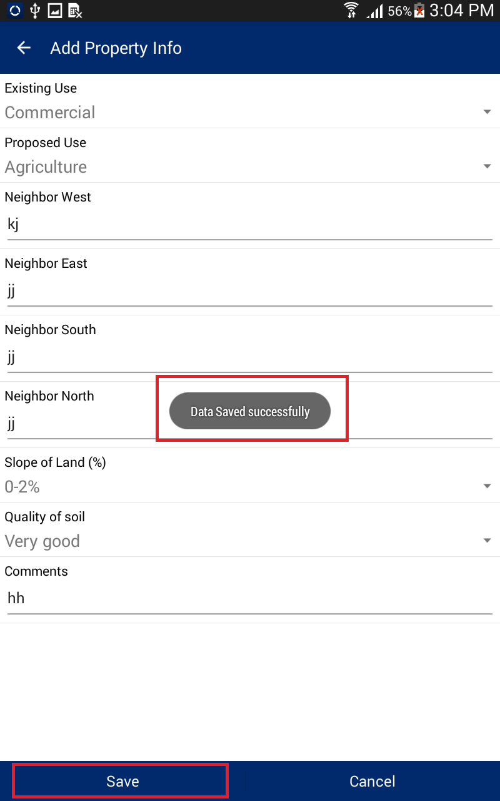Click on ‘Edit Attribute’ button.
3. User will navigate to ‘Capture Attribute’ form and Attributes of corresponding feature will be available in edit mode
4. Edit required attributes
5. Click on ‘Save’ option
6. Application will save updated attribute details and an acknowledge message will be displayed.

## Delete Entry

‘Delete Entry’ feature facilitate user to delete a spatial unit along with all of its attribute data.

**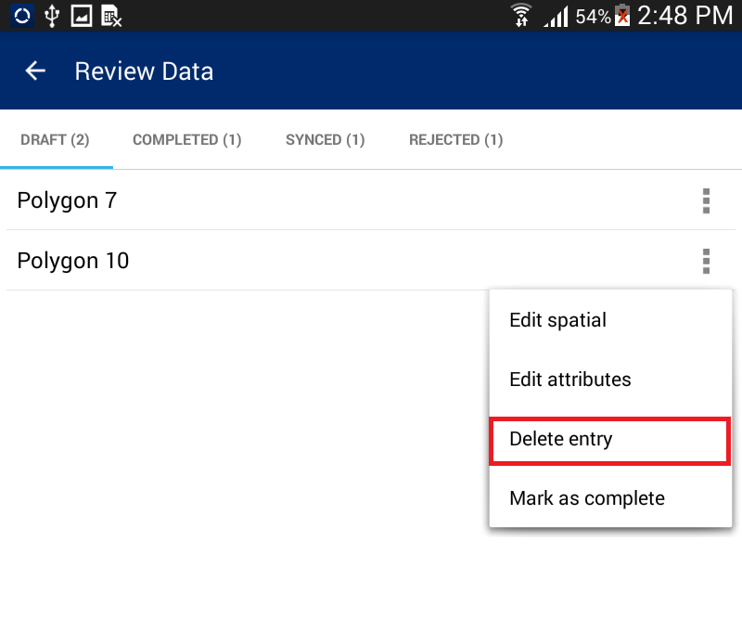Steps:**

1. Click on ‘Delete Entry’ option
2. Application will display a confirmation message
3. 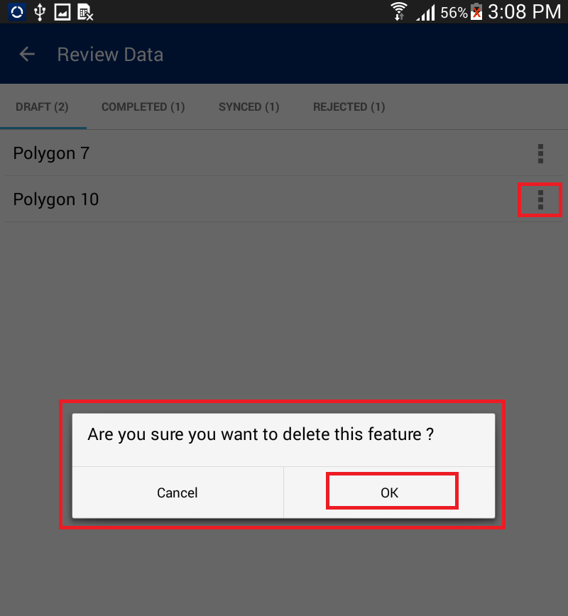Click on ‘OK’ button
4. Corresponding feature along with its attribute details will be deleted

## Mark as complete

This functionality facilitate user to mark a parcel complete, once a parcel is completed. It can be synchronized.

**Steps:**

1. 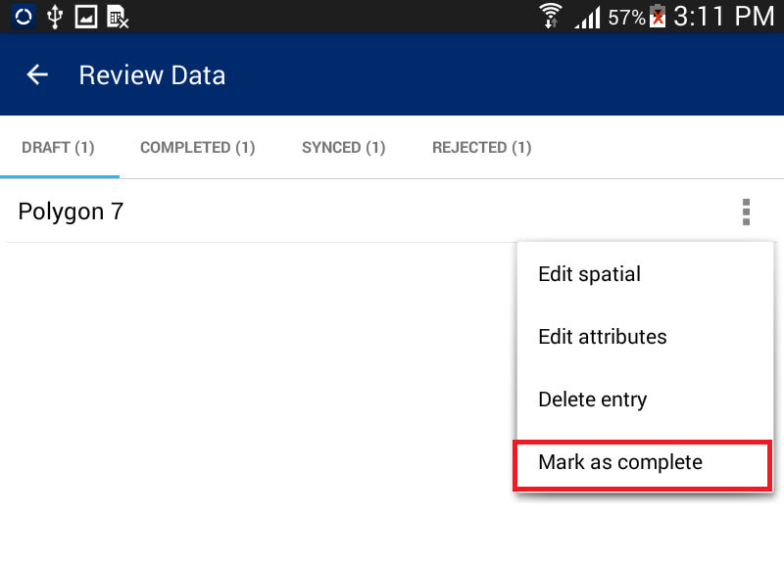Click on ‘Mark as Complete’ option

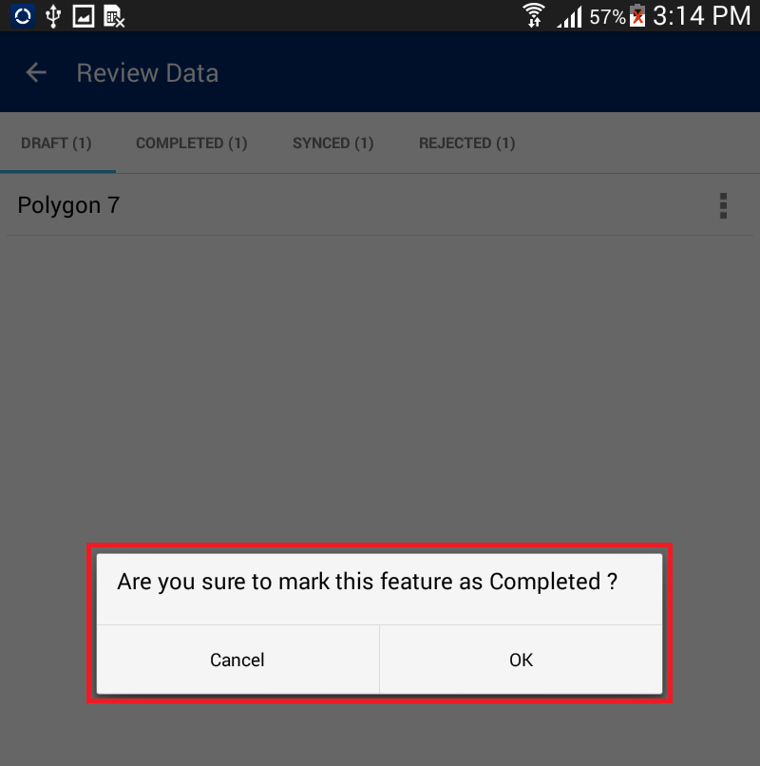

1. Application will display a confirmation message along with ‘Cancel’ and ‘OK’ button
2. Click on OK button
3. 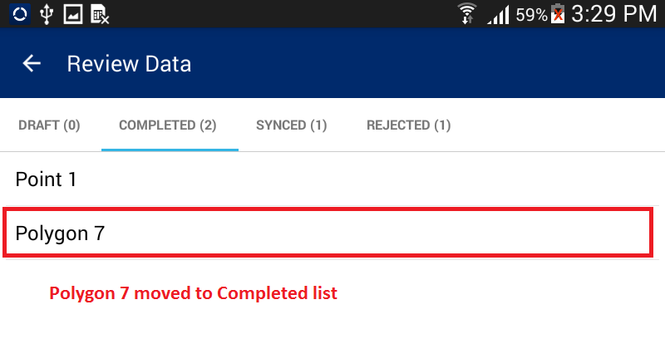Parcel will be completed. It will be removed from ‘Draft’ List and will become available in ‘Completed’ List

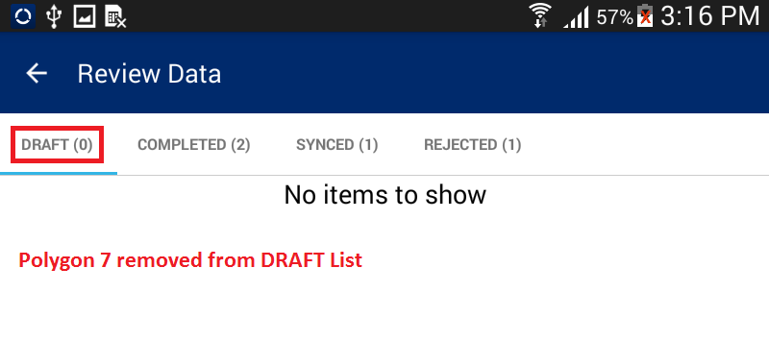

1. Download Data

‘Download Data’ facilitates user to download configuration information and base data of on the device. Top download data, mobile device should be in connected mode i.e. Internet should be available in device.

**Steps:**

1. 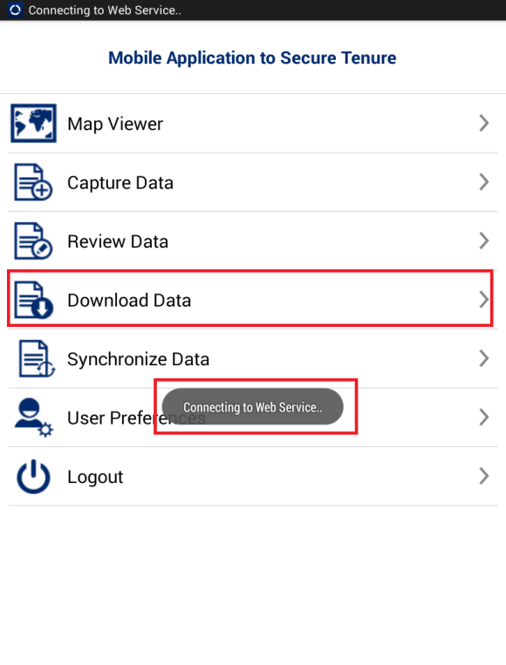User clicks on ‘Download Data’ option available in homepage
2. Application will connect to the remote server and download required data
3. Once Data Download is completed, an acknowledgement message will be displayed

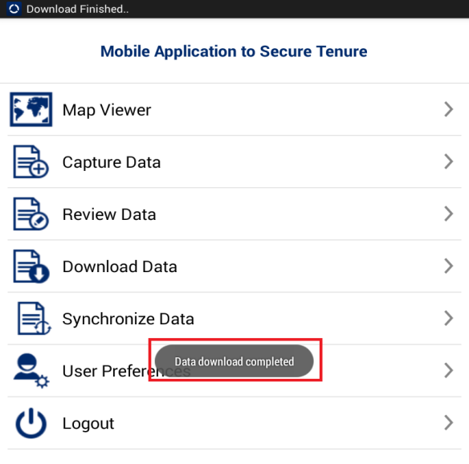

1. Synchronize Data

This functionality facilitates users to submit completed and verified data to back-end cloud server.

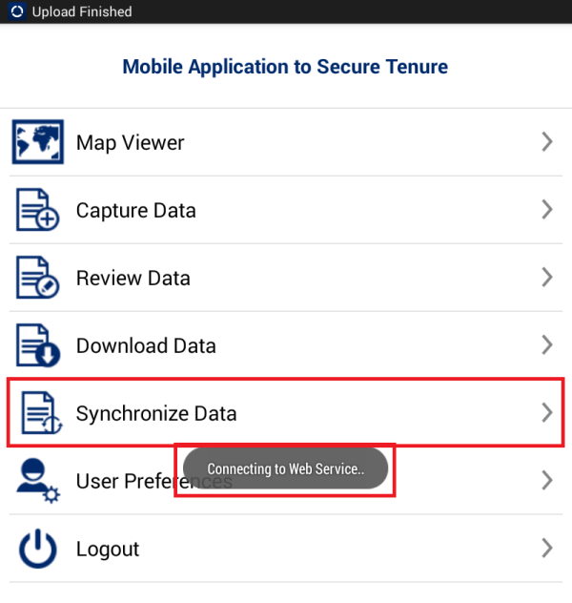 **Steps:**

1. User clicks on ‘Synchronize Data’ option available on Homepage
2. Application will connect to the remote server to upload data
3. 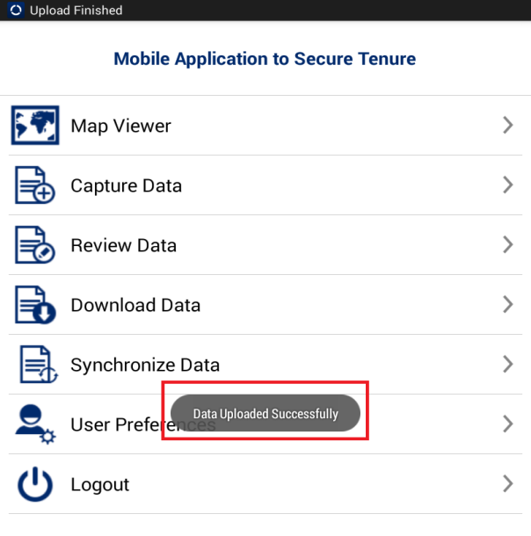Once Data Synchronization is completed, an acknowledgement message will be displayed
4. User Preferences

User Preferences facilitate user to change settings for MAST mobile application. This functionality allow user to change default language, Configure Data collection tools, Configure Sync up and map display.

**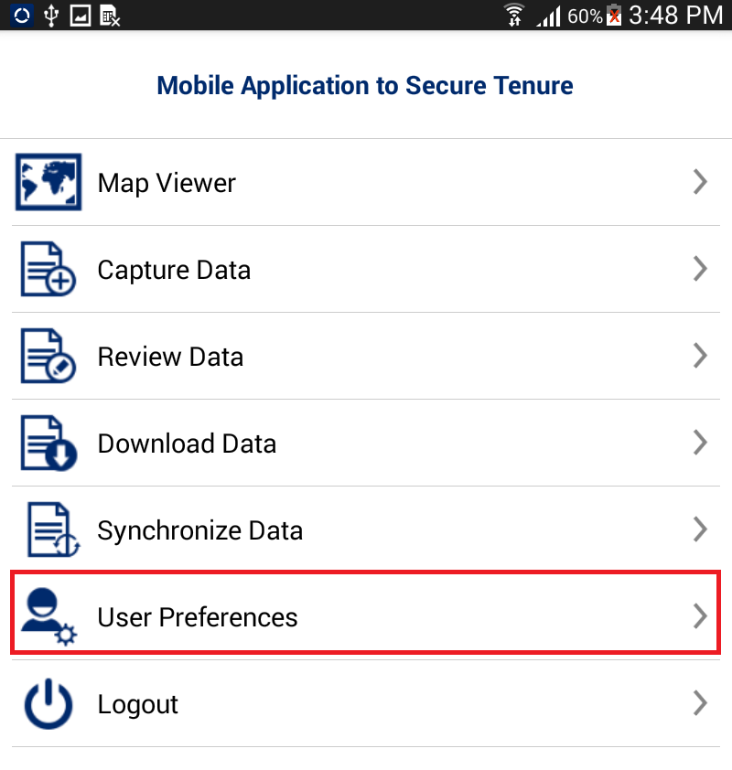**

**Steps:**

1. User clicks on ‘User Preferences' option available on Homepage.

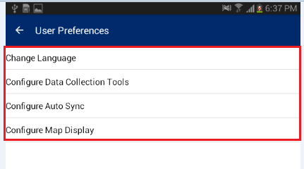

1. User Preferences for will be displayed with following options:
   * + Change Language
     + Configure Data Collection Tool
     + Configure Auto Sync
     + Configure Map Display

# Change Language

This functionality facilitates user to change their preferred language for mobile application

**Steps:**

1. User clicks on ‘Change Language’ option
2. Application will display ‘Change Language’ dialogue
3. Select desired language
4. **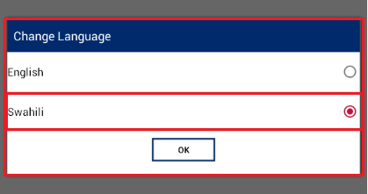**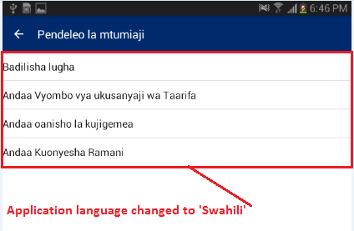Click on OK button, language of MAST application will be changed

# Configure Data Collection Tool

This functionality facilitates user to configure spatial data collection tools.

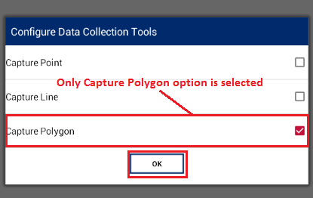**Steps:**

1. User clicks on ‘Configure Data Collection Tool’ option
2. ‘Configure Data Collection Tool’ dialogue box will be displayed with following options
   * + Capture Point
     + Capture Line
     + Capture Polygon
3. User selects options using which he/she needs to be data collection work.
4. Click on OK button
5. 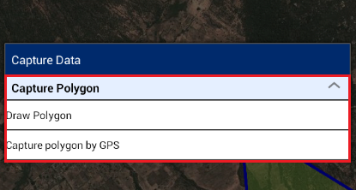Navigate to ‘Capture Data’, and click on Create Data tool
6. Application will show options to create only configured features

# Configure Auto Sync

This functionality facilitates user to configure the sync up settings on the device. They can configure sync up to be 'Auto Sync'. Auto Sync means that the data will be synced automatically to the back-end server whenever internet connectivity is available.

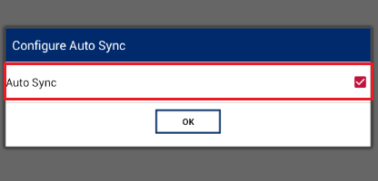**Steps:**

1. User click on ‘Configure Auto Sync’ option
2. ‘Configure Auto Sync’ dialogue box will be displayed
3. Check ‘Auto Sync’ option, if auto syncup is to be enabled
4. Click on OK button

# Configure Map Display

This functionality facilitates user to configure display properties of spatial units on the map viewer. User can configure the color of point, line, and polygon features of vector data layer.

**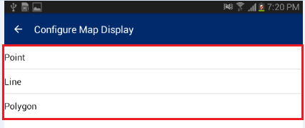Steps:**

1. User clicks on ‘Configure Map Display’ option
2. ‘Configure Map Display’ form will be displayed with following options.
   * + Point
     + Line
     + 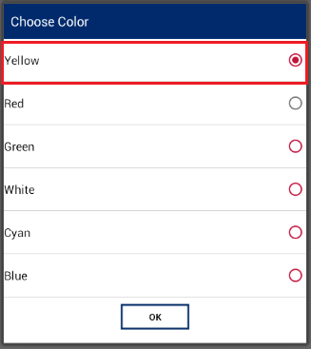Polygon

## Point

This option facilitate user to configure color of ‘Point’ feature.

**Steps:**

1. User clicks on Point option
2. Choose Color dialogue box will be displayed
3. Choose desired color let’s say – ‘Yellow’
4. Click on ‘OK’ button
5. Navigate to Map viewer, Spatial units of Point type, will be displayed as per display settings configured by user

## Line

This option facilitate user to configure color of ‘Line’ feature.

**Steps:**

1. User clicks on Line option
2. Choose Color dialogue box will be displayed
3. Choose desired color let’s say – ‘Red’
4. Click on ‘OK’ button
5. Navigate to Map viewer, Spatial units of Line type, will be displayed as per display settings configured by user

## Polygon

This option facilitate user to configure color of ‘Polygon’ feature.

**Steps:**

1. User clicks on Polygon option
2. Choose Color dialogue box will be displayed
3. Choose desired color let’s say – ‘Blue’
4. Click on ‘OK’ button
5. Navigate to Map viewer, Spatial units of Polygon type, will be displayed as per display settings configured by user
6. Logout

‘Logout’ facilitate user to logout from the application. When user click on logout option, if any of the completed parcel is pending for sync up, Application displays a notification message.

**Steps:**

1. 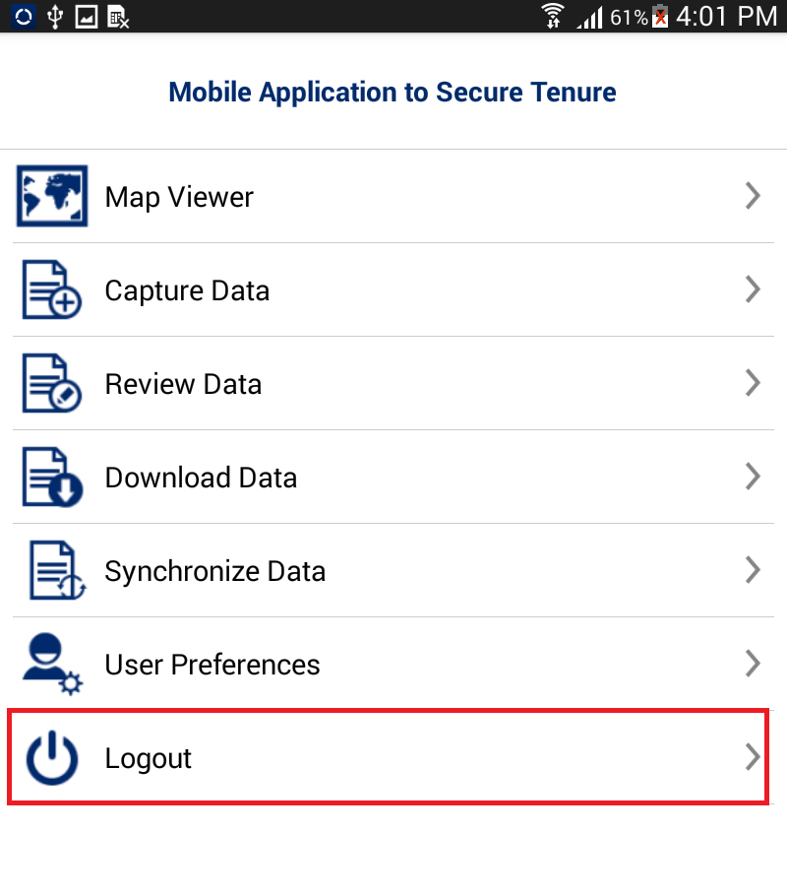User clicks on ‘Logout’ option available on homepage
2. 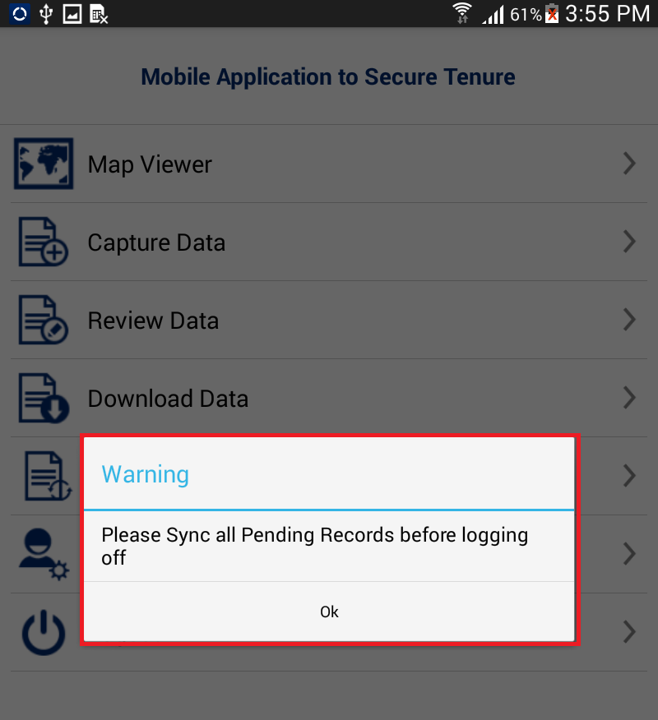If any of the completed parcel is pending for sync up, Application displays a Warning message
3. If there is no pending parcel for sync up, Application displays a Warning message
4. Click on Logout button, User will be logged out from the application.

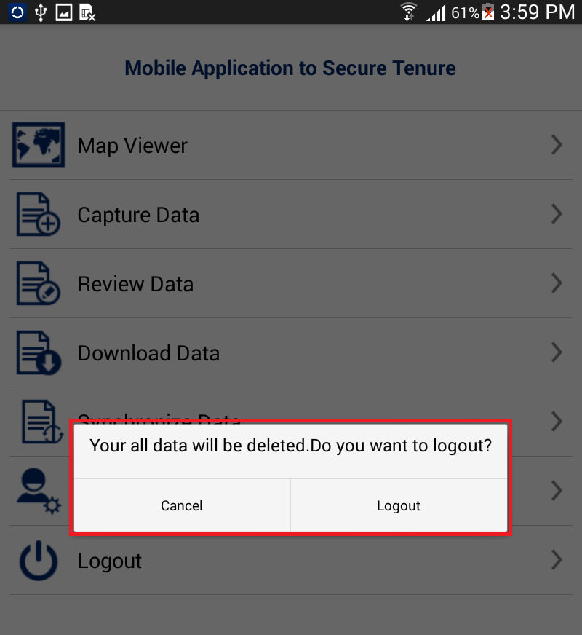

U.S. Agency for International Development

1300 Pennsylvania Avenue, NW

Washington, DC 20523

Tel: (202) 712-0000

Fax: (202) 216-3524

www.usaid.gov